

**Michael Kemper**

**CHALLENGE LAB V4 QUICKSTART**



**Introduction**

The purpose of this document is to provide Skillable’s customers with best practices and information about how to start building Challenge Labs.

#### Background

Challenge Labs are different from traditional step-by-step labs and ask learners to prove their skills by doing instead of following prescriptive step-by-step instructions. Learners learn by doing and, sometimes, failing. That’s acceptable as long as they are failing forward and learning from mistakes.

Challenge Labs may be leveraged across a learner’s skills development journey, which spans from skills acquisition to skills validation. Please refer to the Challenge Labs Use Case section of this document for speciﬁc examples.

**CHALLENGE LABS PRODUCT DEFINITIONS**

**CHALLENGE LAB TYPES**

**CHALLENGE LAB OVERVIEW**

**CHALLENGE LABS USE CASES**

**CHALLENGE LAB VIEWS**

**CHALLENGE LAB QUICKSTART - SETTING UP THE LAB**

**QUICK START CHECKLIST**

**CREATE A NEW CHALLENGE LAB FROM A TEMPLATE**

**ADDING VARIABLES TO A CHALLENGE LAB**

**ADDING VERIFICATION SCRIPTS TO A CHALLENGE LAB**

**ALERT BLOCKS**

**CODE BLOCKS**

**COPY TEXT / TYPE TEXT**

**FONT FORMATTING**

**HIDDEN ITEM SECTIONS**

**HINTS**

**IMAGES**

**KNOWLEDGE BLOCKS**

**NOTES**

**TABLES**

**TOGGLES**

**CHALLENGE LAB STRUCTURE**

**CREATING THE TITLE PAGE**

**CREATING YOUR FIRST REQUIREMENT**

**ADDING THE CHECK YOUR WORK SECTION**

**ADDING THE SUMMARY SECTION**

*Lesson 1 of 25*

# CHALLENGE LABS PRODUCT DEFINITIONS

 **Michael Kemper**

## Background

Challenge Labs are short, scenario-based, hands-on labs that enable learners to validate skills quickly, simply, and effectively. Challenge Labs (also referred to as Challenges) contain varying degrees of clarity and detail in requirements, depending upon type, and contain scored assessments that enables a learner to judge success.

Learners learn by doing and by receiving feedback as they progress through a Challenge.

## Challenge Lab Series

A Challenge Lab Series is a set of related Challenge Labs that are developed in a hierarchical model anchored to a set of skills or learning objectives. A Challenge Lab Series can be used to quickly determine whether a person has the skills needed for a speciﬁc job, and, if not, which skills are lacking.

## Assessments

Assessments can be used to validate learners’ competencies or skill sets and can be based on knowledge or performance. Getting Started Labs use Knowledge-based Assessments or self-veriﬁcation exercises, while Guided, Advanced, Expert and Capstone Challenge Labs use Activity-based Assessments and Performance-based Testing, respectively.

## Knowledge-based Assessment

This format presents learners with a series of questions—multiple choice or short answer—that they are required to answer/verify.

## Activity-based Assessment (ABA)

This format evaluates the learner’s environment in an automated fashion and encourages a try-fail-learn-repeat model.

The learner completes the task that’s presented. The task is then assessed automatically, and the learner receives real-time feedback and guidance on any corrective action needed.

## Evidence-based Testing (PBT)

Similar to Activity-based Assessments, Performance-based Testing engages the learner directly and validates skills by providing the learner with a scored result when all required activities are completed. The scored results are usually presented as pass/fail.

*Lesson 2 of 25*

# CHALLENGE LAB TYPES

 **Michael Kemper**

#### Getting Started Lab

Serving as an introduction to Challenge Labs, a Getting Started Lab incorporates more goal- oriented steps than a Guided Challenge and is designed for the learner who needs to acquire speciﬁc skills before proceeding to the Guided, Advanced or Expert Challenge Labs.

Getting Started Labs are based on a scenario similar to what’s referenced in companion Challenge Labs, but with simpliﬁed instructions that contain tips and hints for guidance. Getting Started Labs should last 60-75 minutes.



**Getting Started labs are no longer developed, however Skillable does continue to maintain existing Getting Started labs.**



A Getting Started lab is intended for learners who are new to a product or technology.

This is a traditional step-by-step lab that provides comprehensive steps on how to complete a task. Each Getting Started lab contains a series of 6-10 tasks that help learners to become familiar with the concepts that are covered in the challenge series.

Each Getting Started lab should take a learner 90 minutes to complete, on average.

#### Guided Challenge Lab

Similar to a traditional lab, a Guided Challenge Lab replaces the click-by-click instructions with goals and objectives, along with detailed hints, images or videos, to ensure the learner can complete the required tasks. Guided Challenge Labs should last 30 minutes and consist of two to four tasks.



A Guided challenge is intended for learners who have basic familiarity with a concept, but who may be lacking experience and knowledge.

Each Guided challenge contains a series of 3–5 related tasks that focus on real-world skills.

This type of challenge should take a learner 30 minutes to complete, on average.

Learners are provided with task-based instructions that simulate a real-world experience.

Instructions are action-based and include the input required to complete the task.

For learners who need some guidance on how to perform a task, detailed hints are provided in the form of step-by-step instructions, videos, and detailed syntax for commands.

Learners can choose to use a hint as needed.

Each task is evaluated by using a script so that learners can determine whether or not they completed the task successfully.

#### Advanced Challenge Lab

This type of Challenge Lab is based on a series of tasks built around an overall objective. It employs Activity-based Assessments and enables learners to determine which tasks they know how to perform and then focus on the tasks they need to work on further. Advanced Challenge Labs should last 30-45 minutes and include three to six tasks.



An Advanced challenge is intended for learners who have a functional knowledge of a product and want to test their level of understanding.

Each Advanced challenge contains a series of 3-6 related tasks that focus on real-world skills.

This type of challenge should take a learner 45 minutes to complete, on average.

For learners who need some guidance, each task contains hints in the form of a URL that takes learners to the product documentation where they can get more information on how to complete the task.

Each task is evaluated by using a script so that learners can determine whether or not they completed the task successfully.

Each task can be repeated, giving learners the opportunity to test their skills and correct any errors they made while performing a task.

#### Expert Challenge Lab

This lab is a true Performance-based Assessment. A learner completes a large conﬁguration task spanning multiple technologies and platforms. The learner receives no guidance and, upon completion, is issued a pass/fail score.

Expert Challenge Labs should last 45-60 minutes and consist of four to eight tasks.



An Expert challenge is intended for learners who want to test themselves to ﬁnd gaps in knowledge and skill.

This is a true, activity-based assessment.

Each Expert challenge contains a series of 3-8 related tasks that focus on real-world skills.

This type of challenge lab should take a learner 60 minutes to complete, on average.

Learners are provided with task-based instructions that contain the input required to complete the task; however, learners are not provided with any information on how to complete the task.

Each challenge lab is scored after all tasks are completed.

#### Capstone Challenge Lab



**CONTINUE**

*Lesson 3 of 25*

# CHALLENGE LAB OVERVIEW

 **Michael Kemper**

## FRAMEWORK: GETTING STARTED + CHALLENGE LABS

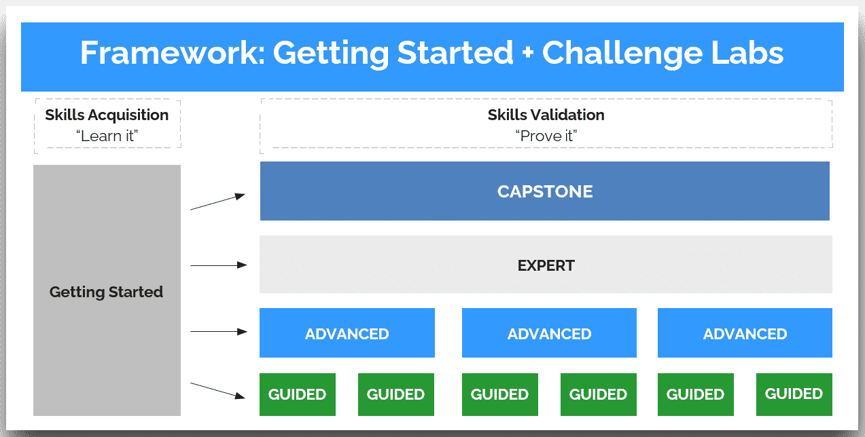

Framework: Getting Started + Challenge Labs

## Challenge Labs Series Development

**Getting Started Labs** are available to a learner needing to acquire speciﬁc skills before proceeding to Challenge Labs.

In a **Guided Challenge Lab**, a learner is required to perform an activity, such as creating an S3 bucket. As needed, the learner receives hints that provide explicit and complete guidance on creating the S3 bucket.

Automated scripting is used to verify whether the learner performed the activity correctly and to provide direct feedback to the learner if corrective steps are needed.

In an **Advanced Challenge Lab**, the learner must perform an activity similar to what was performed in the preceding Guided Challenge Lab, such as creating an S3 bucket. However, in place of explicit guidance on how to perform the activity, the learner is provided a link to product documentation.

Automated scripting is used to verify whether the learner performed the activity correctly and to provide direct feedback to the learner if corrective steps are needed.

**In an Expert Challenge Lab**, the learner is required to perform a signiﬁcant percentage (more than 60%) of the same or similar activities that were performed in all preceding Guided and Advanced Challenge Labs combined. However, the learner receives no guidance for completing the activities. There is only one Expert Challenge Lab per lab series.

 The Expert Challenge Lab uses automated scripts to issue the learner a pass/fail grade. The learner does not receive feedback throughout the lab like they do in Guided and Advanced Challenge Labs.

## Challenge Labs Key Characteristics

**Challenge Labs:**

Get to the point as quickly as possible.

Avoid presenting information until it is needed.

Encourage exploration and learning by “failing fast and failing forward.”

*Lesson 4 of 25*

# CHALLENGE LABS USE CASES

 **Michael Kemper**

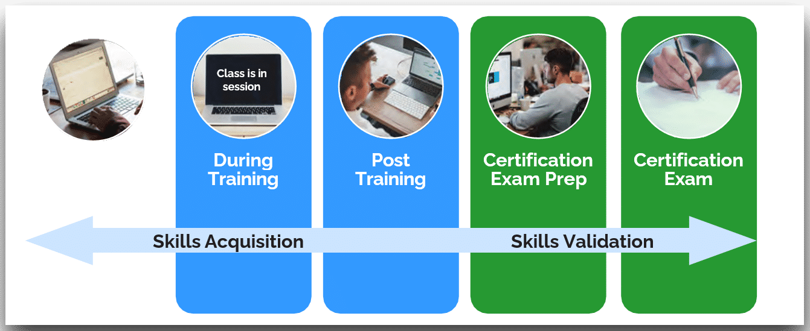

**Challenge Labs support the life cycle of skills development (acquisition to validation).**

## Skills Acquisition

Combine Challenges with existing training activities.

Create a blended learning experience.

Incorporate as pre-class and post-class Assessments.

Extend/add to existing hands-on labs.

Design a stand-alone self-paced subscription (All Access Pass).

Includes Learning Path or Goals associated to a timeline.

Provides the learner freedom to focus on the topics or tasks they choose.

Deliver a Challenge Lab course.

 Provide microlearning by design.

## Skills Validation

Use Challenges to provide additional hands-on practice tied to vendor certiﬁcation exam objectives.

Challenges provide learners with the same model of scoring and requirements they will see on a Performance-based Testing exam.

*Lesson 5 of 25*

# CHALLENGE LAB VIEWS

 **Michael Kemper**

**Launched Lab View**

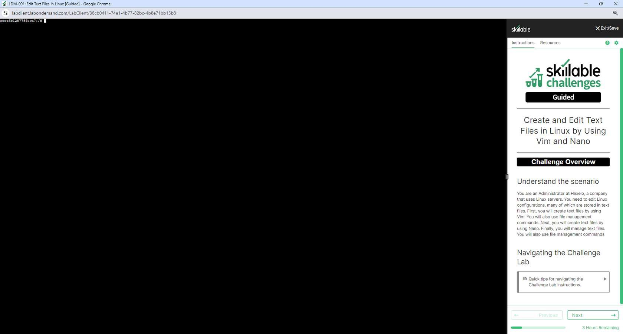

**Edit Instructions Lab View**

I <!--5/l�/2tl2' - C�1!len1•· LD-1-Nlr{l41042) - (CtWertRd to v3.lil usinJ "Nil�- ··> Z <!--lettll/lOMI. Adclt-d/acxl!fie<I fffdt>•<� ""L. R-,,nd excu1 CSS. Den ��HU-->

� <!•• �l*/l� Or..-.c v3 update ...,,1.., ••>

llNSTR\lCTioo<;[J{htl�t· /'rN !ith ,h 1strr<>nttof <O-IIOO&PO!tnttcb1)ltr!$1·Y3·fr-eQ<:kU'l,lin/Tc-p)tltf/Sr<liOO$/inta, *IPQ)*

**

11 >Y::>u or, an ,1A\,.V1r:!1bh(i;lo;b.Udalninr1t,;,r) n,1.�.V1d1ble(ijfob•lC�). • c�1ny th,.t uu1 Linux Hrv,u. YOO ne•C to t<lit Linux confi11Jr1tlono, uny of .,t,tch ue otored in Uxt fllu. lir,t, youwill crHle Un tlle, by ,uing Vi■. Yoo •ill •l•o uH fH• •n•g•-nt c,_..,nd,. NOxt, yoo will cruu tut filu byu11n1 �•..,_ finolly, youwill mo.noge tort tilt<. You •Ill 11«1 U(@ HI• .. �g-•t c.,_.nd,.

" >

*u*

U <!-- kgin ��vi..--nl [l] ••�ti<lf'·•>

"17 •Cruteuxt:fllubyu,in1Vl.ll

19 !INSTRUClIOOS()(lltt�-J!tb itl1$CUOOTCnt roe(IOOXQQ)CnUCtlo)Jrorc·Y,-erM!'l!PCk{M!o/lCMll&lt:1/'iC(fjoos/Illtcl,c..JII) "11 >{!I0.0Wl.t00!) Yau have bun �,m,.,nically <isn«s iM0 the ,�n"'" n ++root++ by using ++flf<•"8r<ll2l++ u the p1uword " 

L=l'r.....,.. ii'_<,,,,_�(•,.,o

ski1loble xex,us-

**o** e **o**

""

71 **skillable**

/

**vvV challenges**

**Guided**

Create and Edit Text Files in Linux by Using Vim and Nano

,,,,hp•(5ho,,6hp••fru•)

�i;. >{•hint] *Expao,d* thh hlM fo,- guldanc•"" u<lng th,. •�•u•• c.,_.,.j.

"U �- �,.. ,,.,tc ti>< folloo,in1 ,_,.,,, to sdtch to the .. u..c.-01.. 1,ar:

,, '

le >""ba>h



)7 ,,,,top,(Sl>owSops•ln,e)

)� >{<-hint] Exp..,.! �hh hlnt �or 1oldtonco "" crtHin1 • directory.



41. ,·--buh

4l ><d,,.,.../u<•rt!l

"46 ',···buh

u ,-.di., 1•�t-filn

**3iffl@,f.H·h4e'll4**

Understand the scenario

V<>U **ar11** an Admlrutrator at 1-18>:elO. a company tl\at usesUnu� ..,,,.,,us. 'l'ou MM *tll* M,l L""°" eonflgu1�lo0M, many 61wr.ierl.a.tfl SlMMln !bl f..,s. l'irit, youwil c<eatt te>rt flie� by u$d\g Vim. l'w wil�so �st fie rnanigemtrrt -cornn.inds. Nexl you will ere,:" lll!Xl Ii� b)' usrng N-"O. Findy, l'Ollwfl m.,n;,ge-1@<1 lin. Yoowil

.. IOUS,,filell'liln.og&IIWn!COrrwnand.._

Navigating the Challenge Lab

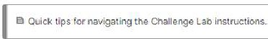

*Lesson 6 of 25*

# QUICK START CHECKLIST

 **Michael Kemper**

Clone the **Challenge Lab** template and create a brand **New Challenge Lab**. **DO NOT EDIT the Template**, you will need it to build the remainder of your **Challenge Labs**.

Add/set your **Variables**. This is where you will specify the lab dificulty, environment, company name, job role, and additional details such as whether to show Hints, hidden toggles or custom messaging.

****Add and Group **Veriﬁcation Scripts.**

Enable S**coring**.

Create the Challenge Lab Title.

Create the Overview and Scenario.

Insert the Tokens for the Global Variables you are using.

Add the Requirements. (repeat for all requirements)

Add Tasks to the Requirements. (repeat for all requirements)

Add Hints or Links to Hints to the Tasks. (repeat for all requirements)

Add Alerts, Notes, or Knowledge Blocks to the Requirements. (repeat for all requirements)

Add Code Blocks (if needed). (repeat for all requirements)

Add Veriﬁcation scripts to Check Your Work. (repeat for all requirements)

Add the Challenge Lab title to the Summary.

List the accomplished Requirements.

List ALL other labs within the series.

Run the lab and test veriﬁcation scripts.

Review formatting.

*Lesson 7 of 25*

# CREATE A NEW CHALLENGE LAB FROM A TEMPLATE

 **Michael Kemper**

## Lab Proﬁle

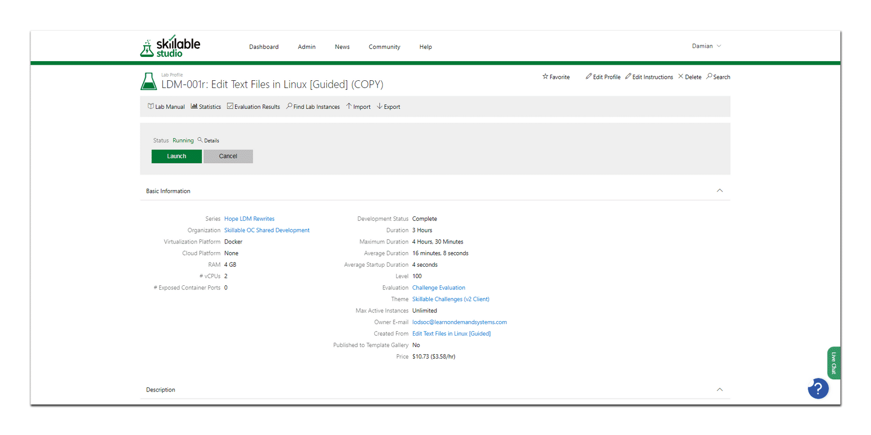

From the Lab Proﬁle page, you are able to edit the Challenge Lab proﬁle settings and instructions, view the lab manual, and/or launch the Challenge Lab.

**CONTINUE**

#### Step 1: Select Edit Proﬁle

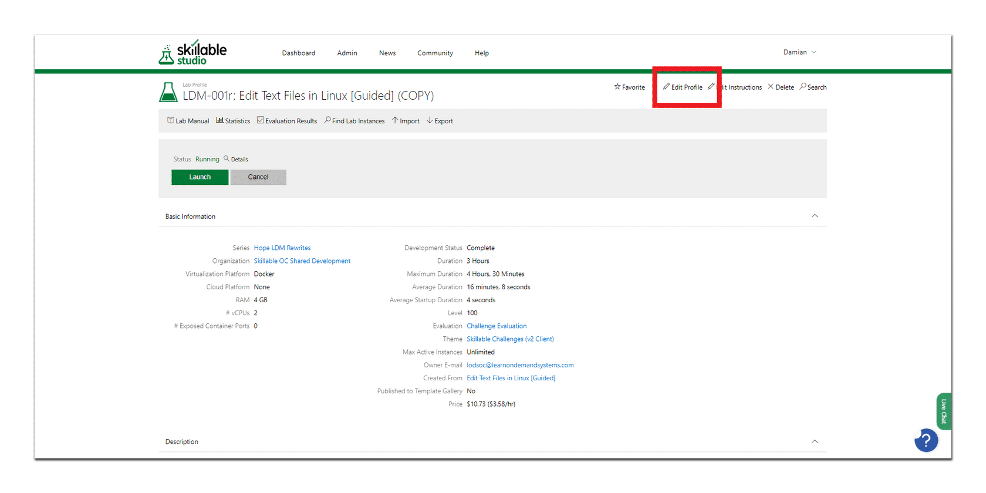

The Lab Proﬁle page with the Edit Proﬁle button highlighted in red.

Select **Edit Proﬁle** from the Lab Proﬁle page to access the Edit Proﬁle page.

**CONTINUE**

#### Edit Proﬁle: Basic Information Tab

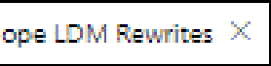

***l!!!f!A*** LDM-001r: Edit Text Files **in** Linux [Guided] (COPY}

**n [d�L>l>Prook:**

Networks Contairier, Volumes Cloud Life Cycle Tags Advanced

Num�r �LD_M_-_0_1r �I•

Name�E_d_i�_i ext ie_s_in_i_n_ux_[�_,u_i_d_ed_,J_(_c_o_P_� �I•

Choose

Organizat on Skilla!Jle OC Shared Oevelopment

Choose

1/ir:ua i::ati n J> atform Docker ***v*** I

Code -b=abr c D

oarertQB Choose D2v2I pmertt Sta,. Gomplete ***V*** I

Dura�on � 11 Hours VI

0rompt **ser to =XtE-nd I me lhyl** 15

IMimi�es Whe 10

IMinut,es R-emain

ln this Challenge Lab, *'lfO* will leam t:> oilizi?�he,¥i"' and

**vi**

**Ev::iluat-on** I Ch.alLe,nge Evalua.tion **X**

Choose

Advertising Cam□*a* **gn** I None I Choose

=t ediccrs.

**.:ind se- a v-=iriEcy of file manage nt tools.ro ma - ge JO r texr.:: liil:5..**

No!e::Onoe *'lfO* begin the Cha lenge La you win t Ile able to pa.use. saee, or re m to y r Ohallenge Lal>.l'lea.se errs re·that *yo* ha,,., 5€t

**a.side e.no g'h time to com;plea:e the Cha'lle-nge L-=b lbefDrE y::>u Si!�nt.**

L: el I 00

-

C�rride Start P·age 0

Sa.vel\s.

Cancel

**Jes.crip:'on**

Enable Bug Reportng **fr.I**

3ug eport= ,ail Addre-ss Q I su;pport@leamo:n<lemand.2endes1l;:.com

Owner E-mail loclsoc©learnondemandsystems.o

The **Basic Information** tab allows you to change the Lab Number, Name, Series, Description and more.

**CONTINUE**

#### Step 2: Create a New Challenge Lab Number



The Challenge Lab template Number defaults to **V3-Challenge Lab Template**.



**fl [d�LJl>Prolik:**

- LDM-001r: Edit Text Files **in** Linux [Guided] (COPY)

Networks Contair,ers \o\Jlumes Cloud Life Cycle �ags Advanced

Numb;;,r LOM-0()1,

Name �E_d_ir._i_ex_1 1e_s_in_i_n_ux_[e:_,u:_i_d_ea_J:_(_c_o_P_YJ �I•

Series , ,ope LDM Roewri�es X I Choose

Organica: on 'S!,illa!Jle OC Shared **;,elopm:ent**

Choose

**Virtua i::ation P atf rm**

eke, ***v*** I

Code Lab=abr c D

arertQB

Choose

D2v2lopn ant Sta. s G<>mplete

Duracon 3

Jrompt User to **::x** :nd ""ime **l!'il** ByI 1s

Level I 00 **VI**

**v** I

11 Hours VI

IMi ur.es,*Wile*

10

IMinutes R<:main

Evalua: on I Ch,alr,enge Eva ua.tion **X** Choose Ad·,ertising ,:amoa **gn** I None I Choose

In this Chaaenge La. *'JO*

**)E::.::::rip:on** Nor.e: Once *'JO* llegin the Cha lenge La yo wiH I Ile a e to pause. sa•,e. or re m to y , Ohaaenge Lal>.l'lee.se enscrre·that yo have·set as" e eno g'h ime to com;plece the Cha'llenge Lab lbefare y<>u s«,r..

En�ble !'.ug eportIng **l!'il**

3ug eport email Addre-;so I suppo,t@le.am:,ndemar>dl2endes1l::.com

**Owner Na mi::**

Owner E-mail loclsoc@ arnori:f:-rnandsys,tems;.mm

-

Cvemde Sta,t Page D

Sa.veAs

Cancel

In this example, we will be using **LAB-001** as the Lab **Number**. The Challenge Lab template defaults to **V3-Challenge Lab Template**.

****On the Basic Information tab, in the Number textbox, replace **V3- Challenge Lab Template** with **LAB-001**, and then press **Tab** to advance to the **Name** textbox**.**

**CONTINUE**

#### Step 3: Create a New Challenge Lab Name





� LDM,�001r:Edit Text Files **in** Linux [Guided] (COPY)

Numbler I LOM-0()1,

Name Edi�fext les in inux [Guided] (COPY)

Serie, Hope *LDM* R>ewri�; X I

Choose

Organi�a:oon Skilla!Jle OC Shared D€velopment

**Choose**

1/ir.ua i:cation P atfo1m

eke• ***v*** I

C de Lab=abrc D

oa,ertQB

Choose

Dev2I pn 2m Sta_ , GDJnplete

**vi**

**vi**

Jrompt serto ::x :nd ,me II ey l�1_s

level I 00 **VI**

� IMimi�es Whe �1-0 -�IMinutes Rema1n

Evalua::,on I Cna1EI nge Evafua.tion **X Choose**

Adve ·sing ".:am □a **gn** I None I

Choose

**Duracon** :!: II **Hours**

Enable E'.ug Reporting II

ciug �epor=t a,itI,,ddress01su;ppo rt@le,amo.ndemarw.zendesl:.com

**Own.er Na mi::**

Owner E-mail [lodsoc@leamonde.ma.nds](mailto:lodsoc@leamonde.ma.nds)�stems.ocm

-

Dl<erride Sta Page D

Save As.

Cancel

111this Challenge La.b, yo

**aiOO .se-a v-=iri'E!cyof fire management tools.ro man=i-ge your te>rn: fil:!E;.**

No�e-:O: nce *yo* begin the Cha lenge Ls you will t Ile a\Jle to pause. sa,,e, or re m to y • Ohallenge Lal>.l'lea;e enslfre•that yo have·set

**aside e.no gh ime to complee the Cha'lle,nge L�b lbef,:::ue y:iu -sri:-=11:.**

We will be using **New Challenge Lab Name** as the Lab **Name**. By default, the Challenge Lab Name defaults to **Challenge Lab Template - (V3) (COPY)**.

****On the Basic Information tab, in the Name textbox, replace **New Challenge Lab Name** with the name of your new Challenge Lab, and then press **Tab** to advance to the **Series** textbox**.**

**CONTINUE**

#### Step 4: Change the Challenge Lab Series

|  |  |  |  |  |  |  |  |
| --- | --- | --- | --- | --- | --- | --- | --- |
| **fl [d�LJl>Prolik:**  - LDM-001r: Edit Text Files **in** Linux [Guided] (COPY)  Networks Contair,ers \o\Jlumes Cloud Life Cycle  Numb;;,r ._L0_,.,_1-_o_(}_fr .l•  Name Edir. fext les in inux [Gu:ided] (COPY] | | | | | | �ags | Advanced |
| Series | , ,ope | *LDM* | Roewri�es X | I | Choose | | |
| Organica:oon Slilla!Jle OC Shared **ielopm:ent** Choose  **Virtua i::ation P atf rm** eke, ***v*** I  Code Lab=abr c D  arertQB Choose D2v2lopn ant Sta. s G<>mplete **v** I  Duracon 3 11 Hours VI  Jrompt User to **::x** :nd ""ime **l!'il** ByI 1s IMi ur.es,*Wile* 10 IMinutes R<:main Level I 00 **VI**  Evalua: on I Ch,alr,enge Eva ua.tion **X** Choose  Ad·,ertising ,:amoa **gn** I None I Choose  In this Chaaenge La. *'JO*  **)E::.::::rip:on** Nor.e: Once *'JO* llegin the Cha lenge La yo wiH I Ile a e to pause. sa•,e. or re m to y , Ohaaenge Lal>.l'lee.se enscrre·that yo haVE•set as" e eno g'h ime to com;plece the Cha'llenge Lab lbefare y<>u s«,r..    En�ble !'.ug eport1ng **l!'il**  3ug eport email Addre-;s o I suppo,t@le.am:,ndemar>dl2endes1l::.com  **Owner Na mi::**  Owner E-mail loclsoc@ amori:f:-rnandsys,tems;.mm  - Cverride Sta,t Page D  Sa.veAs Cancel | | | | | | | |

We will be using our **Sandbox** as the Lab **Series**. By default, the Challenge Lab series defaults to **Challenge Labs Sandbox**.

****On the Basic Information tab, to the right of the Series textbox, select the **Choose** button**.**

On the Choose Lab Series page, in the Name search box, enter the name of your **Sandbox**, and then select **Search**.

Select your sandbox from the list of **Lab Series Found** , and then select **OK**.

Back on the Basic Information tab, in the Series textbox, press

**Tab** to advance to the **Organization** textbox**.**

**CONTINUE**

#### Step 5: Change the Challenge Lab Organization



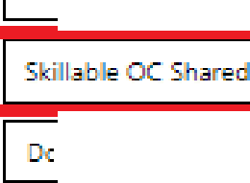

**fl [d�LJl>Prolik:**

- LDM-001r: Edit Text Files **in** Linux [Guided] (COPY)

Networks Contair,ers \o\Jlumes Cloud Life Cycle �ags Advanced

Numb;;,r I LOM-0()1,

Name �E_d_ir._i_ex_1 1e_s_in_i_n_ux_[e:_,u:_i_d_ea_J:_(_c_o_P_YJ �I•

Series , ,ope LDM Roewri�es X I Choose

**Organi:;:a:;on**

**ielopm:ent**

Choose

**Virtua i::ation P atform**

eke, **v** I

Code Lab=abr c D

arertQB

Choose

D2v2lopn em Sta. s G<>mplete **v** I

Duracon 3 11 Hours VI

IMinutes R<:main

Evalua: on I Ch,alr,enge Eva ua.tion **X** Choose

Ad·,ertising ,:amoa **gn** I None I

Choose

Jrompt User to ::x :nd ""ime **l!'il** ByI 1s

Level I 00 **VI**

IMi ur.es,*Wile*

10

-

Cverride Sta,t Page D

Sa.veAs

Cancel

In this Chaaenge La. *'JO*

**)E::.::::rip:on** Nor.e: Once *'JO* llegin the Cha lenge La yo wiH I Ile a e to pause. sa•,e. or re m to y , Ohaaenge Lal>.l'lee.se enscrre·that yo have·set as e eno g'h ime to com;plece the Cha'llenge Lab lbefare y<>u s«,r..

En�ble !'.ug eportIng **l!'il**

3ug eport email Addre-;so I suppo,t@le.am:,ndemar>dl2endes1l::.com

**Owner Na mi::**

Owner E-mail loclsoc@ amori:f:-rnandsys,tems;.mm

We will be using **Skillable OC Shared Development** as the Lab **Organization**. By default, the Challenge Lab series defaults to **Skillable OC Shared Development**.

****Verify that the Challenge Lab **Organization** is set to **Skillable OC Shared Development.**

If the **Organization** is not set to **Skillable OC Shared Development,** select the **Choose** button directly to the right of the **Organization** textbox.

On the Choose Organization page, in the Name search box, enter

**Skillable OC Shared Development**, and then select the

**Search** button.

Select **Skillable OC Shared Development** from the list of

**Organizations Found**, and then select **OK**.

****Back on the Basic Information tab, in the Organization textbox, press **Tab** to advance through until you reach the **Duration** textbox**.**

**CONTINUE**

#### Step 6: Change the Challenge Lab Duration

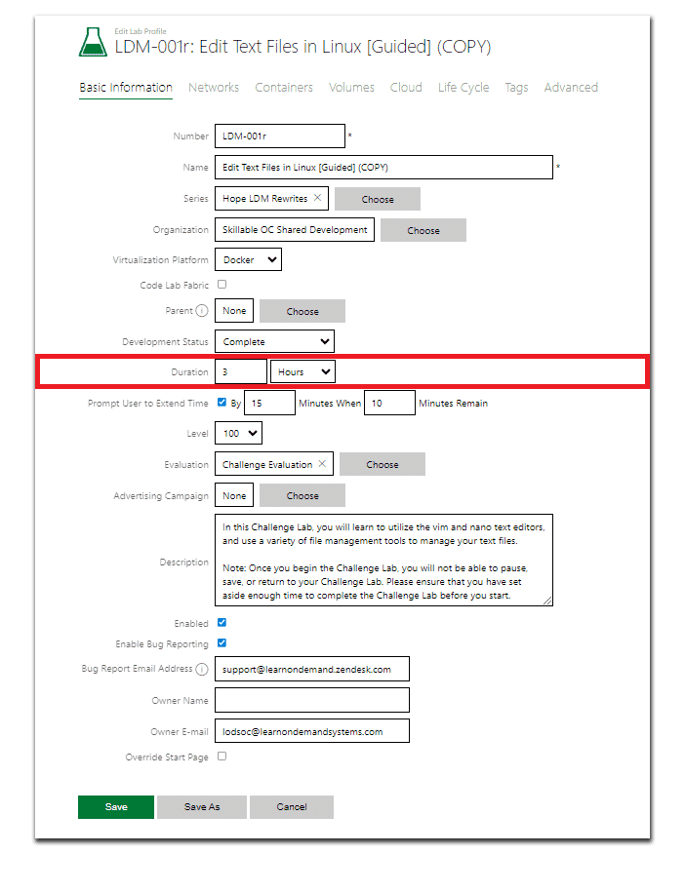

By default, the Challenge Lab **Duration** is set to (1) hour. It is important to note that different lab levels have different durations. For example, a Guided Challenge Lab

might have a duration of (30-45) minutes, while an Advanced Challenge Lab could be (45-60) minutes, and an Expert or Capstone Challenge Lab could easily be in excess of

(1) hour.

****On the Basic Information tab, in the Duration textbox, set the duration to **(1) Hour**, and then press **Tab.**

**CONTINUE**

#### Step 7: Update the Challenge Lab Description

|  |  |  |
| --- | --- | --- |
| **fl.. [drt�Profile**  ***l!!!f!j.*** LDM-001r: Edit Text Files ill Linux [Guided] (COPY)  ash: Information Ne:works Contairer, Volume, CIOl,d Life Cycle �ags Advanced  Number ._L_D_�_1_-0_(}_1_, ,I•  Name ._E_rn_,•_.i extF_11e_s_·_,n_i_n_ux_[�_,_u_id_e_d_J_!C_O_P_� �I•  Serie, Hope LDM Fwwri= X I Choose  Organi,at on Skilla!Jle OC Shared .-elopmeflt Choose 1/ir.ua i::atioo F' atform Docke• ***v*** I  C de L=b=abrc D  **0arertQ** B Choose  Devel **prt ;-m Sta: s** I G<>mplete **vi**  **Durac.on** I � II **Hourrs *v*** I  Jrompt **ser to =Xv=nd I mem** eyl 15 IMi utes Whe 10 IMinutes Rema1n Level I 00 **vi**  **Ev::iluaton** I Cnallenge E\'3luation **X Choose**  Ad·,e osing (:am□a **gn** I None I Choose | | |
| **JE::.r:rip:on** | In this Charlenge Lab, yo wilI leam t:> -liz.e the•Yim and aoo,= sdioors.  **and se- a variecy of file management tools.to man:.-ge yo r � fil?.:;.**  Note-:Once yo begin the Challenge La )1<l will t Ile a\Jle to pause. sase, orre m to y , Ohallenge LaI>. Plea.se ens re·that )1<l have·5€t aside eno gh time to complee the Challenge Lab !before y<>u e<art. |  |
| ,r,abled II  Enable g fleport:ing II  **3ug eport :. 1aiI .Addre--;� Q s:uppo rt@le,arn::mdemaru:L.z.1:ndes.!k..c:om**  **Own.er Nami::**  0v,.-ner E-mail [lodsoc@l2amondema.nds](mailto:lodsoc@l2amondema.nds)�stems.oom  - 0.-.rride Sta . Page D  Save As Canoel | | |

By default, the Challenge Lab **Description** text displays:

In this Challenge Lab, you will create an Advanced Challenge Lab.

Note: Once you begin the Challenge Lab, you will not be able to pause, save, or return to your Challenge Lab. Please ensure that you have set aside enough time to complete the Challenge Lab before you start.

*The following is an example of a Challenge Lab* ***description****:*

In this Challenge Lab, you will implement an Azure load balancer. First, you will create an Azure load balancer. Next, you will conﬁgure a backend pool for the load balancer, and then you will conﬁgure an HTTP health probe. Finally, you will create a load balancing rule.

Note: Once you begin the Challenge Lab, you will not be able to pause, save, or return to your Challenge Lab. Please ensure that you have set aside enough time to complete the Challenge Lab before you start.



**Challenge Lab descriptions generally follow the following format:**

**In this Challenge Lab you will _______. First, you will** **, and then**

**you will _______. Next, you will _______, and then you will** **_.**

**Finally, you will** **_.**

On the Basic Information tab, in the **Description** textbox, enter your new Challenge Lab description.

**CONTINUE**

#### Step 8: Select Save As

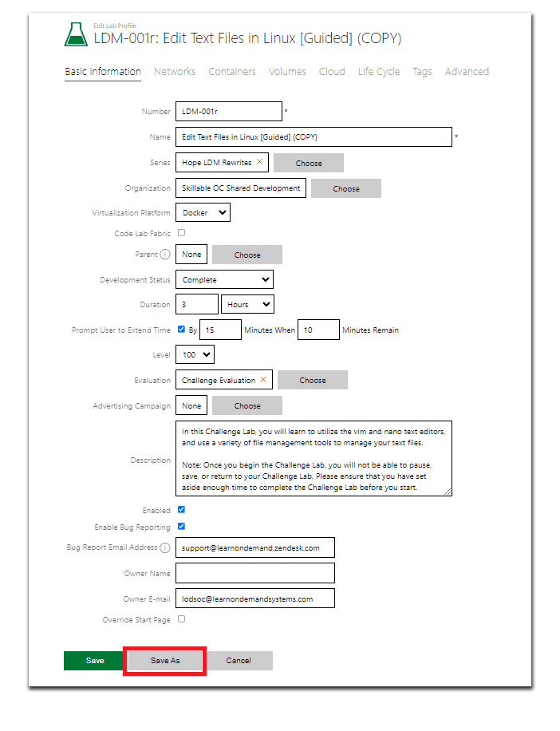

**IMPORTANT!** Be sure to select **Save As**, instead of selecting **Save. Save As** will save the current Challenge Lab template as your new **Challenge Lab**, while simply selecting

**Save** will overwrite your template.

Select **Save As** to create your new Challenge Lab template.

**CONTINUE**

#### Step 9: Verify the Save As Window changes

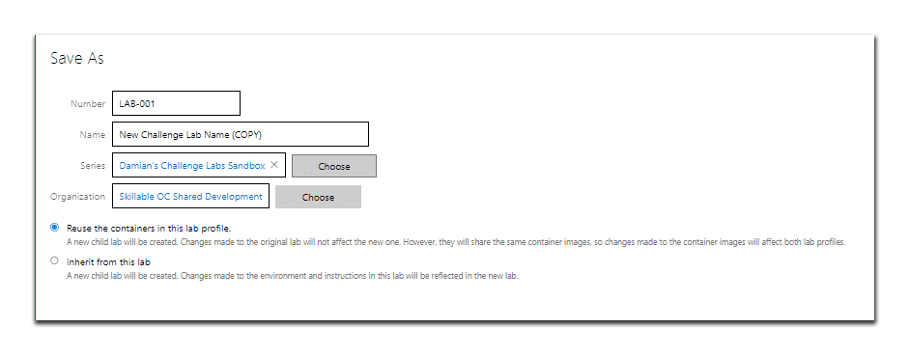

The Save As window with a new Challenge Lab Name and Number using the Sandbox series, Skillable OC Shared Development Organization, and Clone this lab selected.

**\*For Labs with only VM's.**

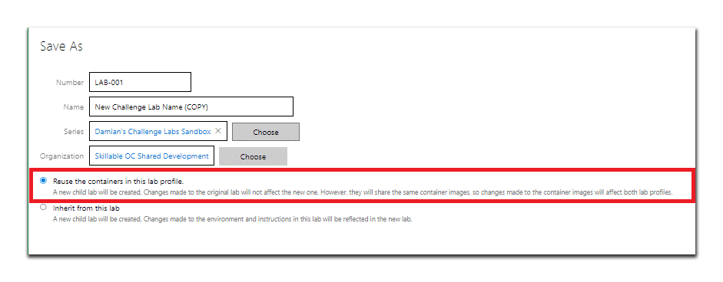

The Save As window with a new Challenge Lab Name and Number using the Sandbox series, Skillable OC Shared Development Organization, and Reuse the virtual machine proﬁles in this lab proﬁle selected.

On the Save As window, in the Number textbox, enter **LAB-001**, and then select **Tab** to advance to the **Name** textbox.

In the Name textbox, enter your new **New Challenge Lab Name**, and then select **Tab** to advance to the **Series** textbox.

In the Series textbox, enter your new **Sandbox Name**, and then select **Tab** to advance to the **Organization** textbox.

In the Organization textbox, enter **Skillable OC Shared Development**, and then verify that **Clone this lab** is selected.

Select **OK** to save create your new Challenge Lab template.

**CONTINUE**

#### Your Cloned Challenge Lab

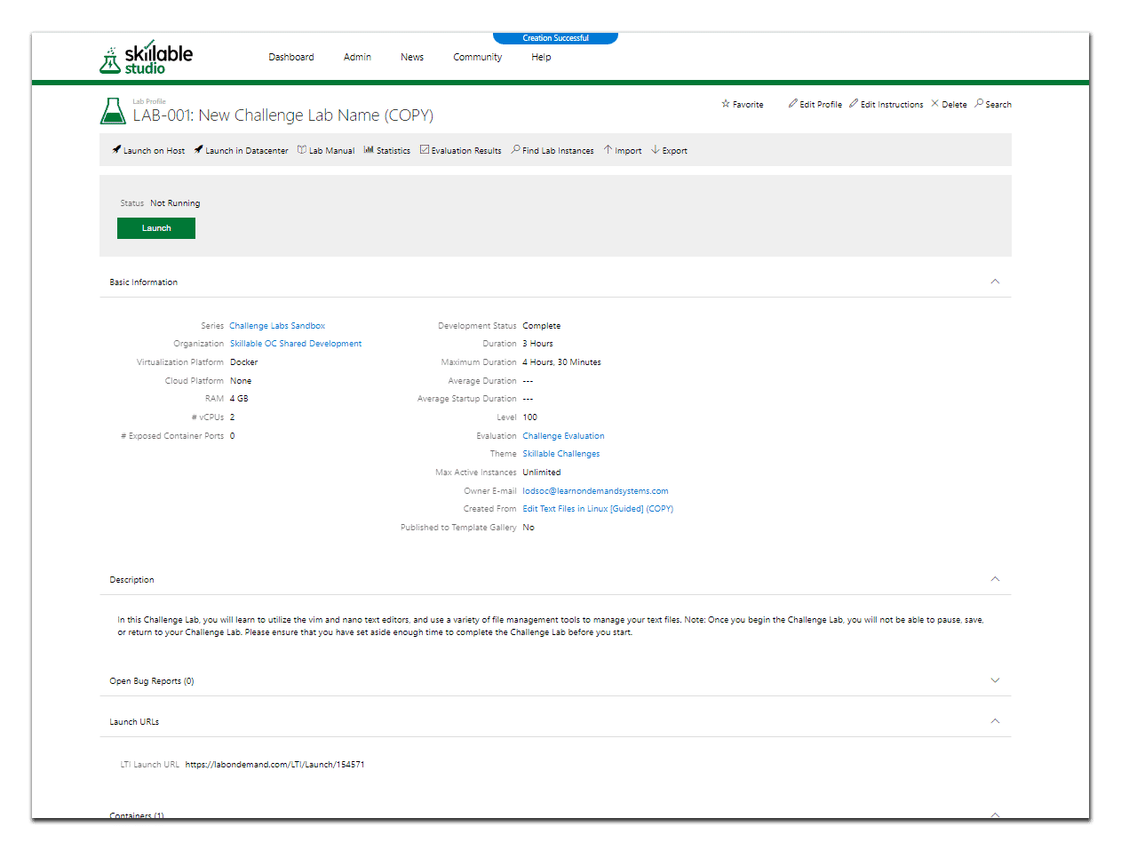

Your cloned Challenge Lab template.

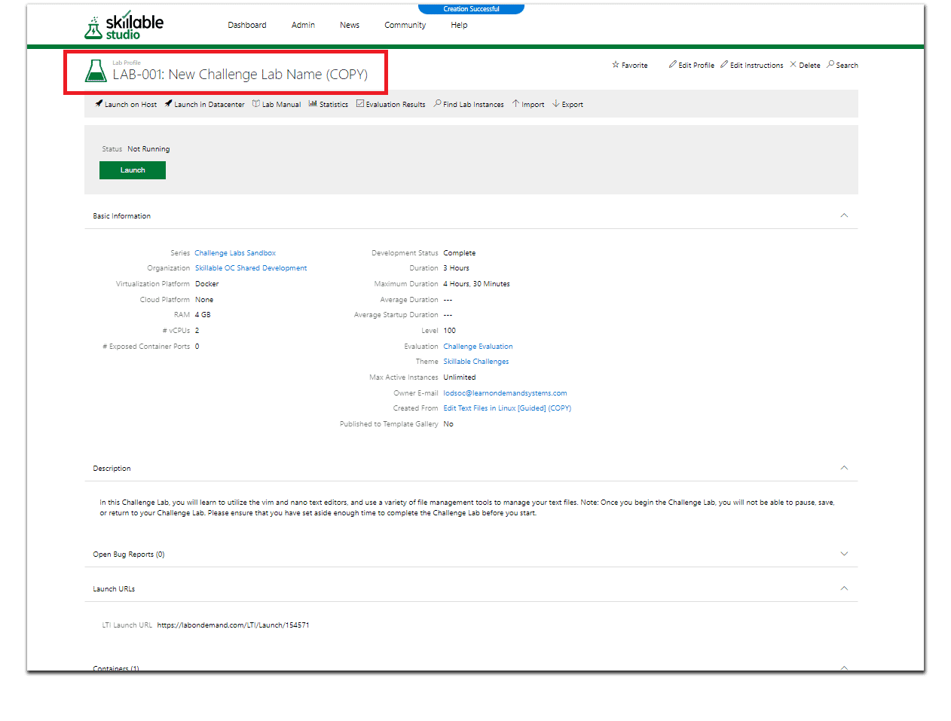

Your new Challenge Lab **Title** highlighted in **Red**.

### Congratulations! You have successfully Cloned your template and are ready to create your New Challenge Lab.

*Lesson 8 of 25*

# ADDING VARIABLES TO A CHALLENGE LAB

 **Michael Kemper**

## Creating Your Challenge Lab Variables

The following step-by-step instructions will help guide you through the process of adding/setting your Challenge Lab variables.

#### The Lab Proﬁle Page

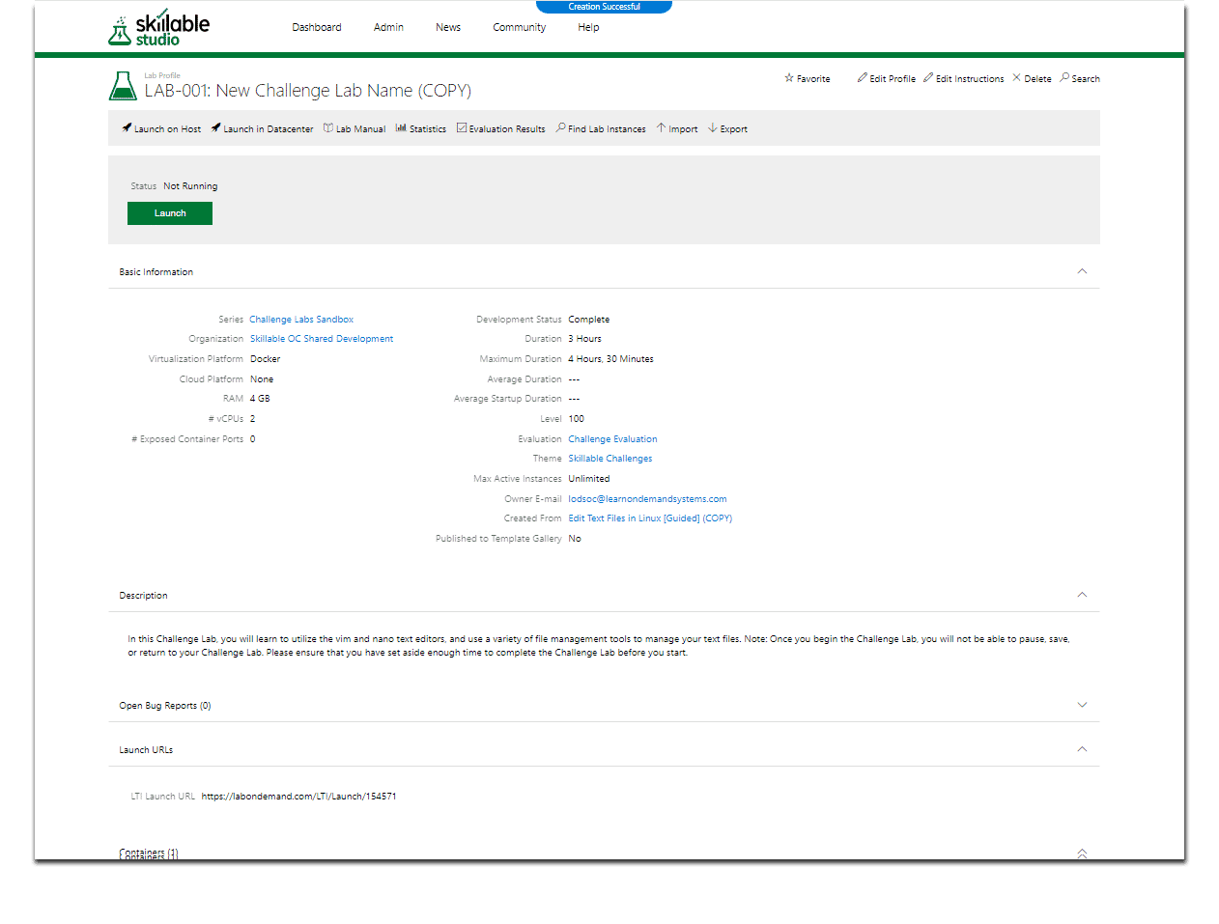

From the Lab Proﬁle page, you are able to edit the Challenge Lab proﬁle settings and instructions, view the lab manual, and/or launch the Challenge Lab.

**CONTINUE**

#### Step 1: Select Edit Instructions

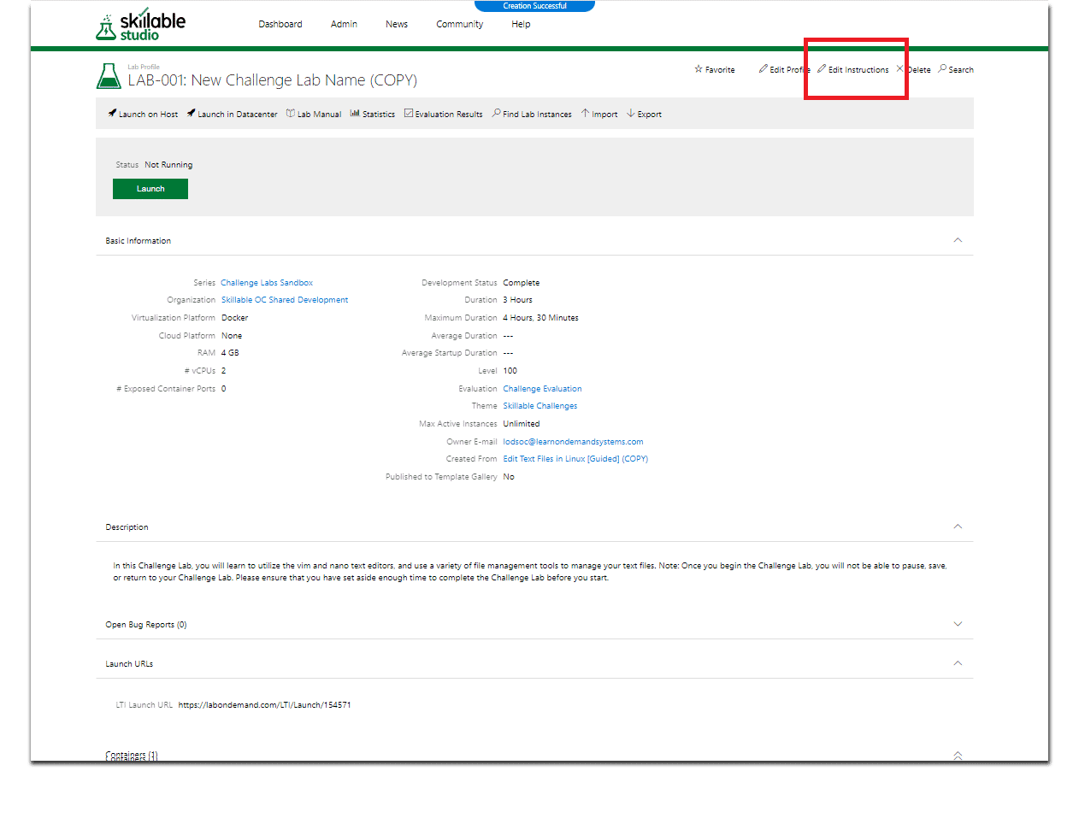

The Lab Proﬁle page with the Edit Instructions button highlighted in **red**.

Select **Edit Instructions** from the Lab Proﬁle page to access the Edit Instructions page.

#### The Edit Instructions Window

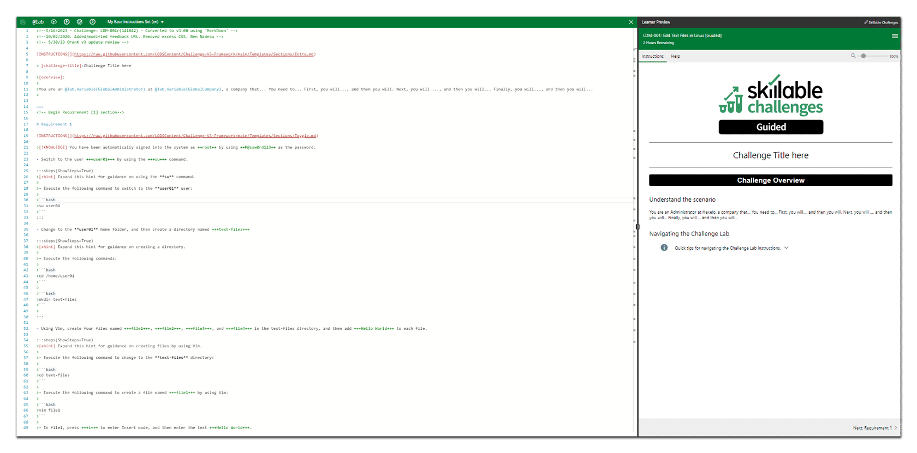

The Edit Instructions window with the iDLX editor and markdown script on the left, and lab manual visible on the right.

**CONTINUE**

#### Step 2: Select the Tokens, Variables, and Replacements Button (@lab).

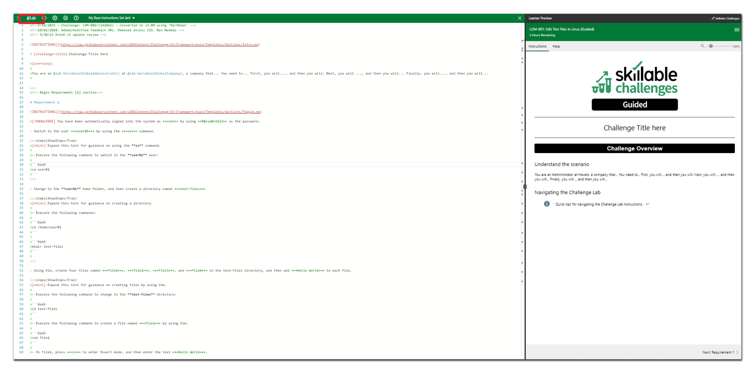

The Add Lab Variables button highlighted in **red** in the upper left corner of the Edit Instructions window.

Select the **@Lab** icon located in the upper left-hand corner of the Edit Instructions window to access the Lab Variables.

#### The Tokens Tab

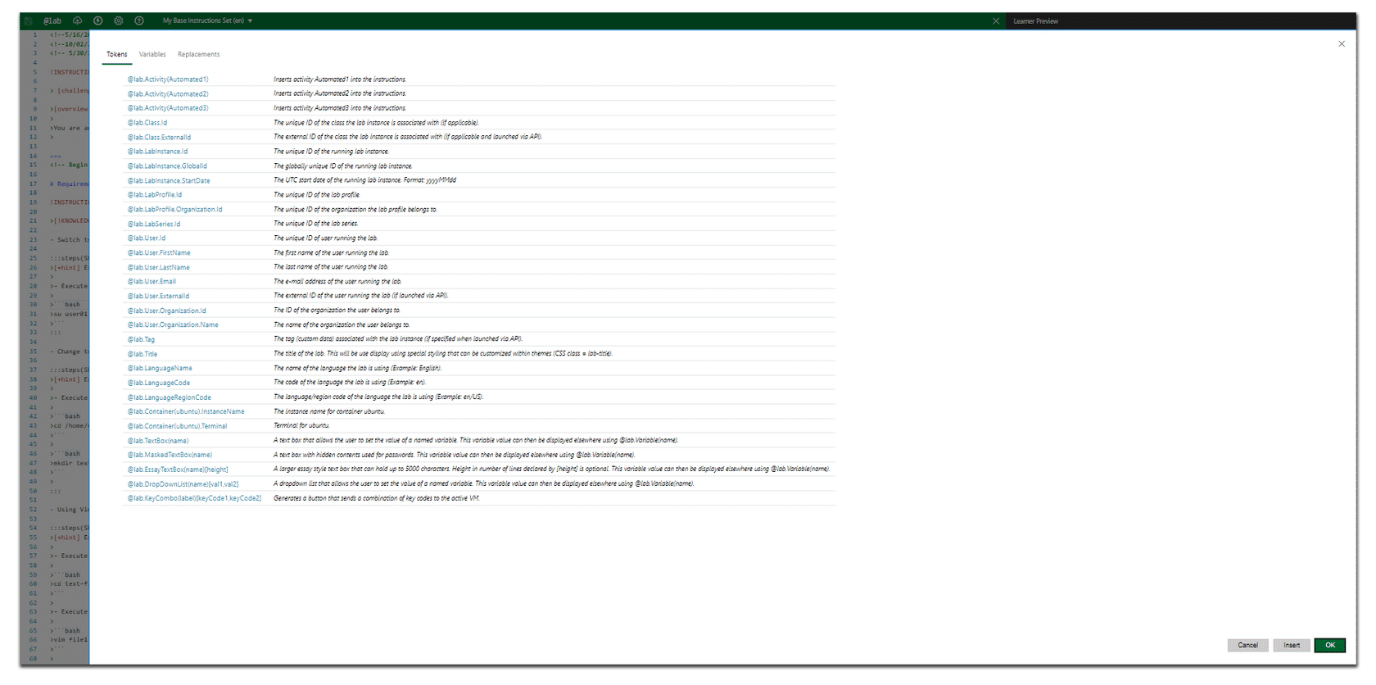

Once you select the **@Lab** icon, the Lab variables page opens placing you on the

**Tokens** tab.

**CONTINUE**

#### Step 3: Select the Variables Tab

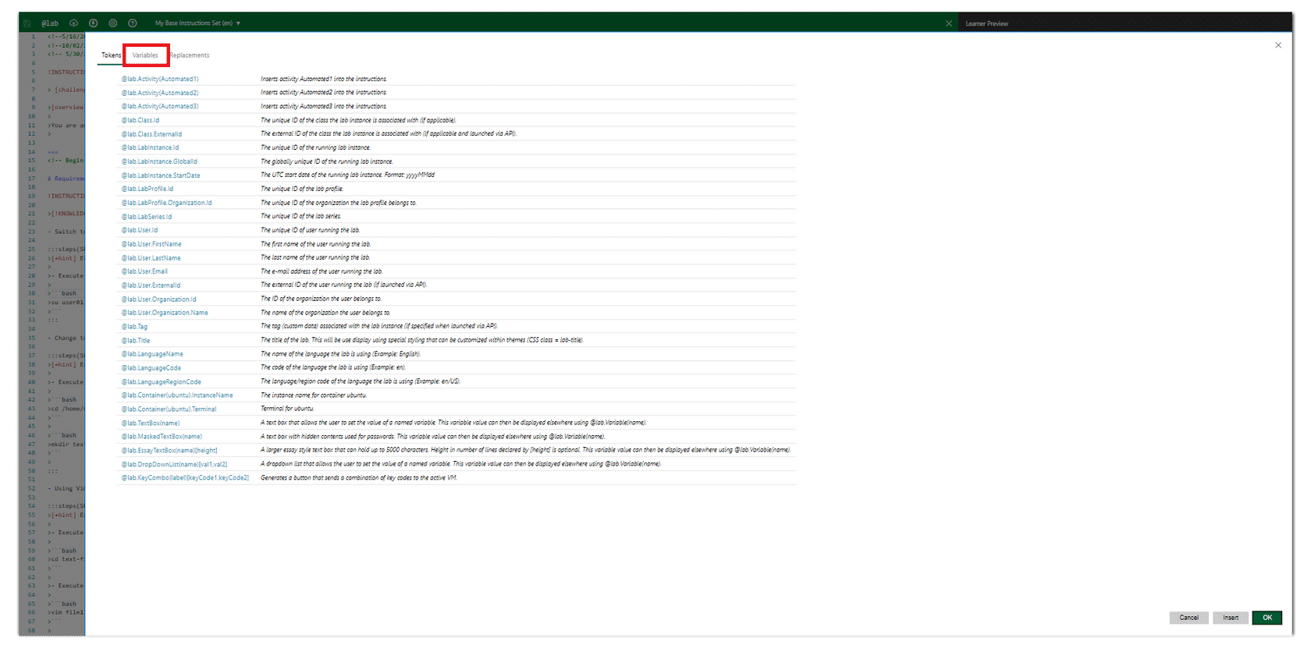

The **Variables** tab highlighted in **red** in the upper left corner of the Edit Instructions window.

Select the **Variables** tab located in the upper left-hand corner of the Edit Instructions window to access the Lab Variables.

**CONTINUE**

#### The Variables Tab

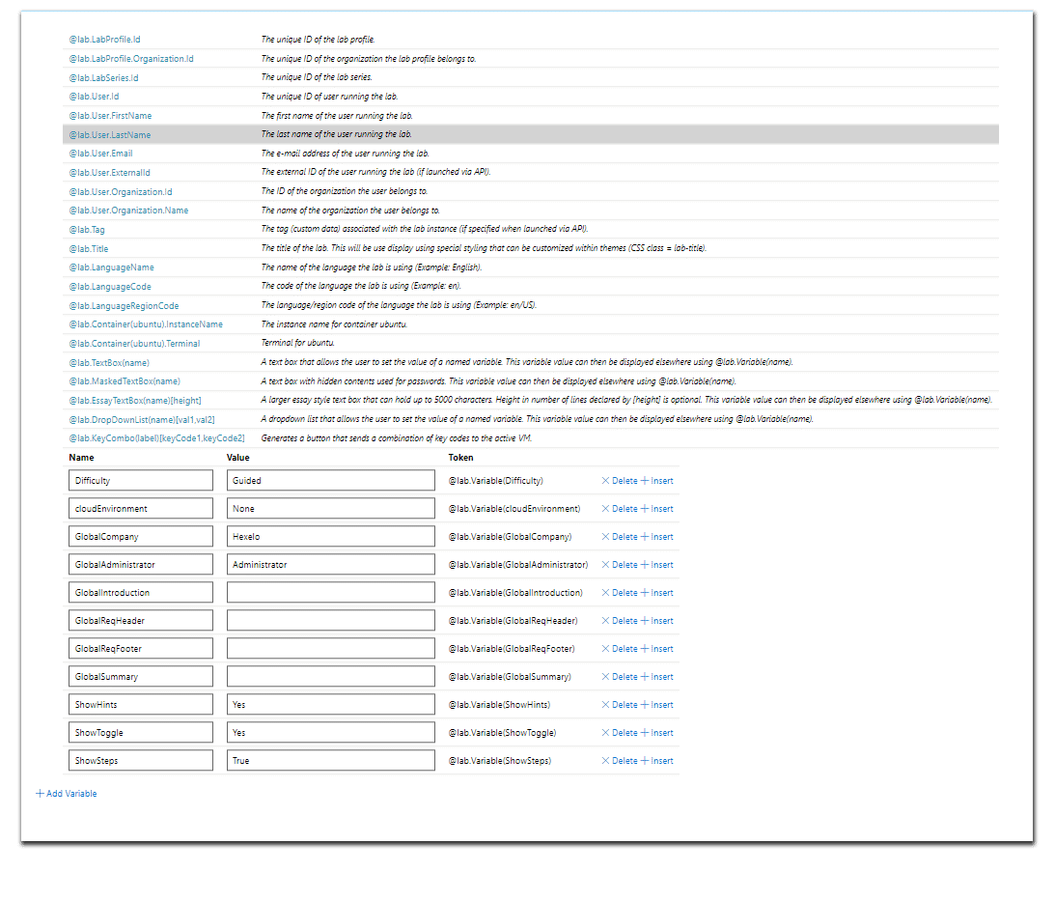

The above image shows all of the variables which are included by default in a new Challenge Lab.

**CONTINUE**

#### Step 4: Set the Lab Diﬃculty

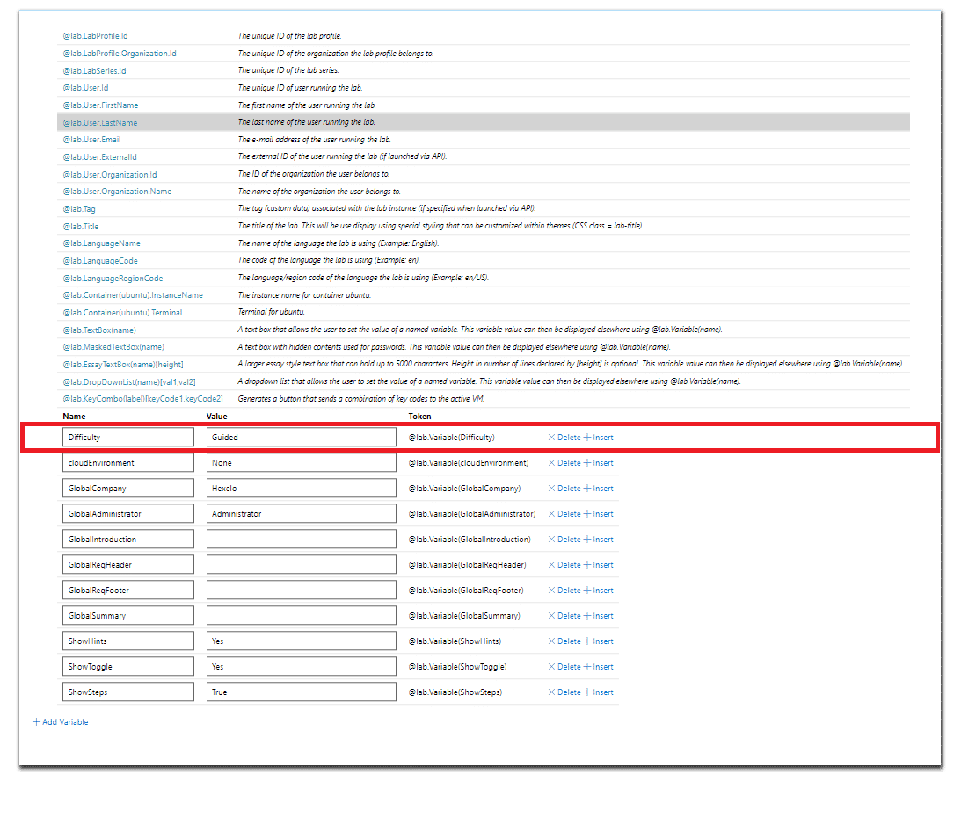

The lab **variables** tab with the **Dificulty** variable highlighted in **red**.

The **dificulty** variable should be set according to which lab you are building. In the above screen capture, the Challenge Lab is set to **Advanced**, which means the author intends for this lab to be an Advanced Challenge Lab. Other options include: **Guided**, **Expert**, and **Capstone**.

On the variables page, enter a value of **Advanced** for the lab dificulty, and then select **Tab** to advance to the **CloudEnvironment** variable.



By entering **Advanced** as the diﬃculty level, we are preparing an

**Advanced** Challenge Lab.

**CONTINUE**

#### Step 5: Set the Lab Cloud Environment

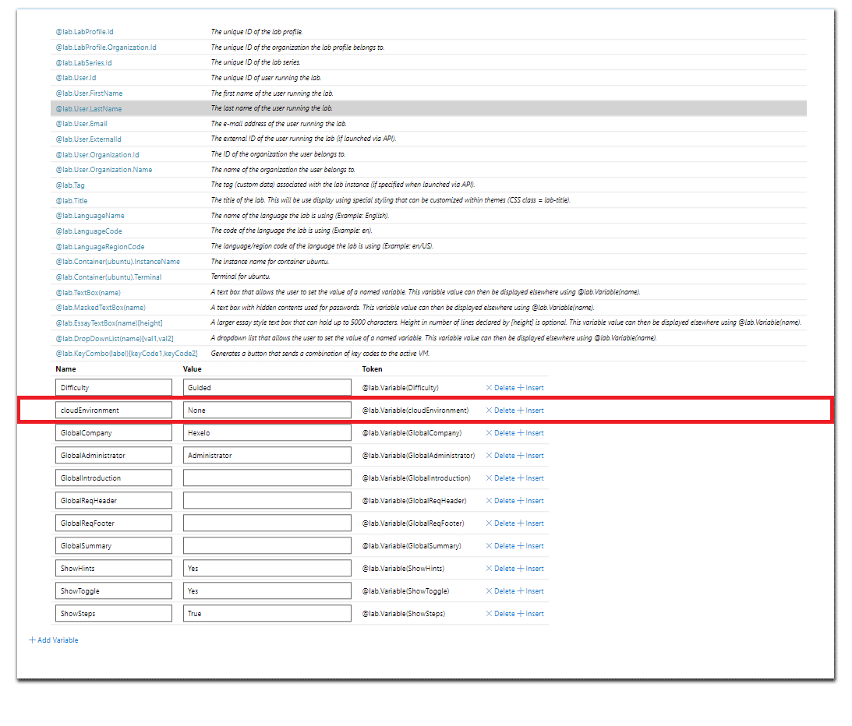

The lab **variables** tab with the **CloudEnvironment** variable highlighted in **red**.

The **cloudEnvironment** variable should be set to **CloudSlice** if you are building a Challenge Lab that requires a Cloud Environment. If the **Value** ﬁeld is empty, the Challenge lab will default to **No Cloud Environment** and the Cloud related verbiage located below the Challenge Lab overview will not display. In the above screen capture, the Challenge Lab is set to **CloudSlice**, which means the author intends for this lab to be a Challenge Lab that requires a Cloud Environment.

On the variables page, enter a value of **CloudSlice** for the CloudEnvironment, and then select **Tab** to advance to the

**GlobalCompany** variable.

**CONTINUE**

#### Step 6: Set the Company Name

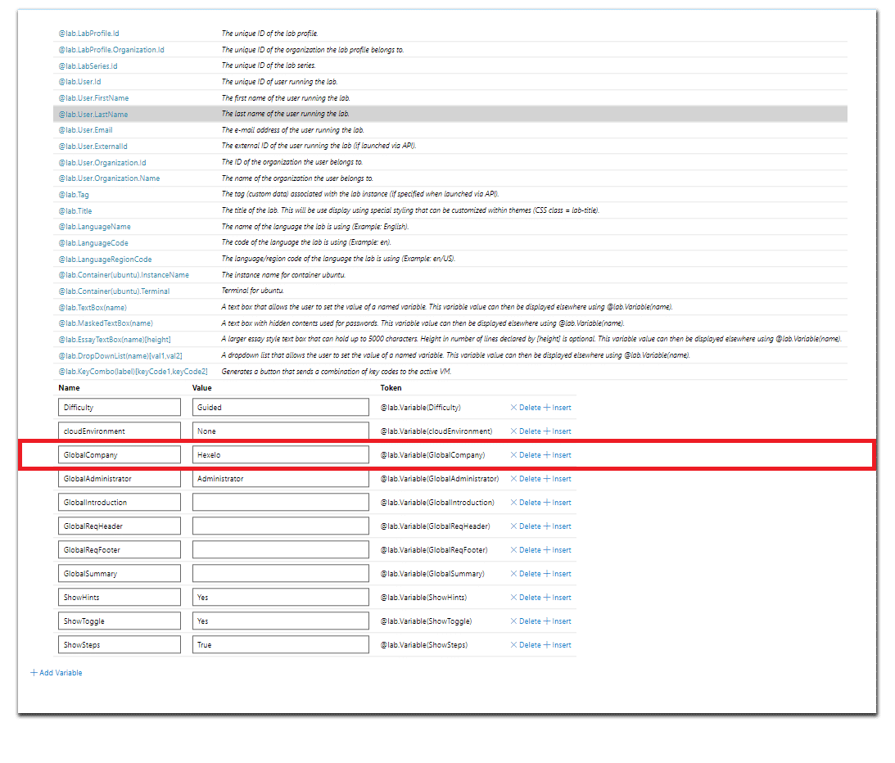

The lab **variables** tab with the **GlobalCompany** variable highlighted in **red**.

The **GlobalCompany** variable is, by default, set to **Hexelo**. This name can be changed to accommodate any Company Name, and changing the value here will update all occurrences of the Company Name within the Challenge Lab.

On the variables page, enter a value of **Hexelo** for the GlobalCompany, and then select **Tab** to advance to the **Global Job Role** variables.

**CONTINUE**

#### Step 7: Set the Job Role

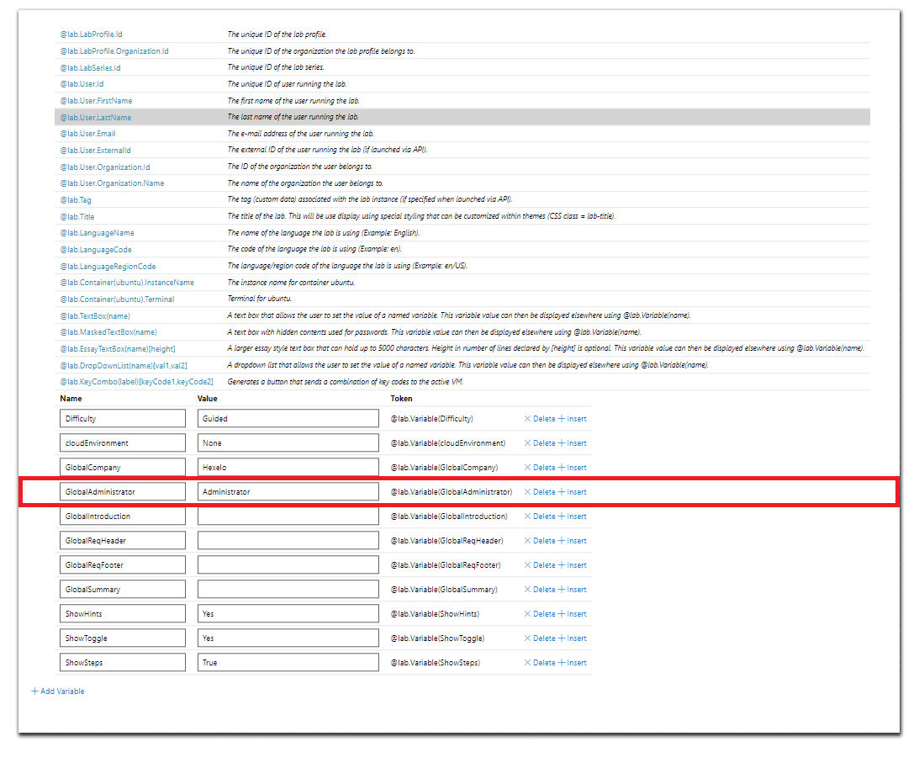

The lab **variables** tab with the **Global Job Role** variables highlighted in **red**.

In the above screen capture, the **Global Job Roles** are selected. None of these values need to be changed. Select the Job Role which you wish to use in your Scenario, and simply insert the @lab.variable(JobRole) in place of the actual Job Role. You will only use 1 of these Job Roles for your Challenge Lab. All Job Roles must fall within one of the above categories. While, these do not need to be edited, you will need to select a job role and insert the Token into your Challenge Lab.

For example, if the Challenge Lab is written for an Administrator, you would insert **@lab.variable(Administrator)** in place of the word **Administrator**, within the markdown of your Scenario. More on this when we discuss **Scenarios**.

On the variables page, review the provided **Job Role** variables, and then select **Tab** to advance to the **GlobalIntroduction** variable.

**CONTINUE**

#### Step 8: Set the Introduction, Summary, Header, and Footer

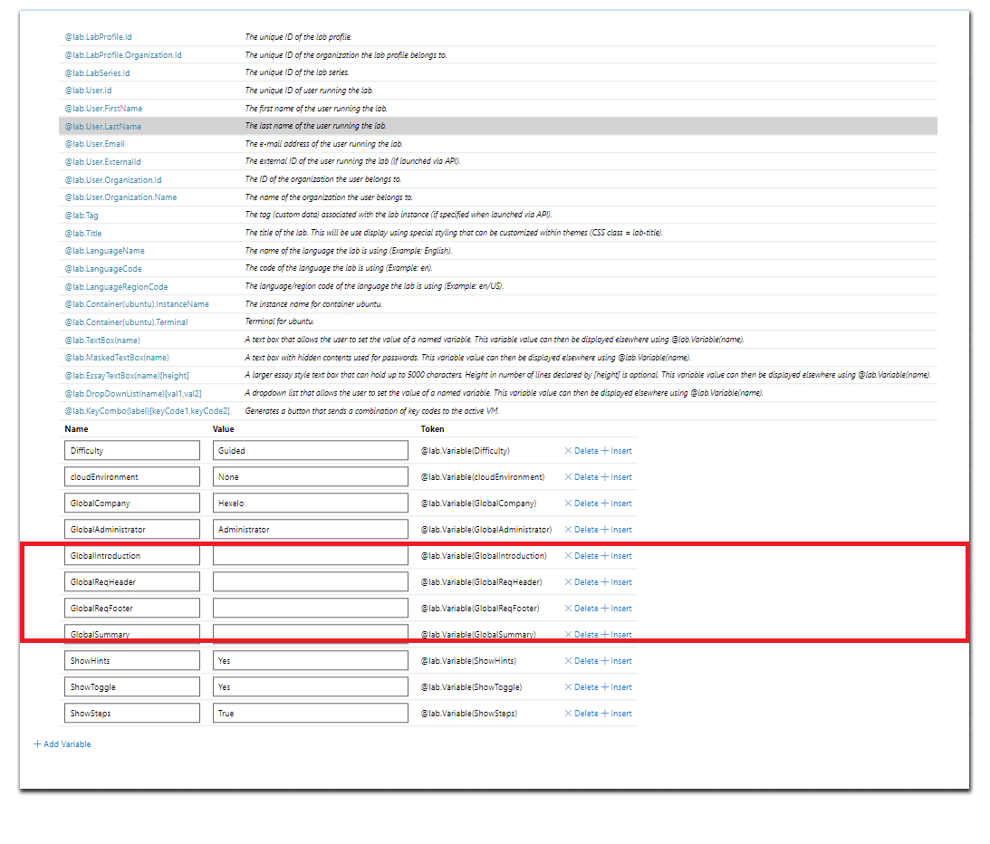

The lab **variables** tab with the **GlobalIntroduction, GlobalSummary, GlobalReqHeader, and GlobalReqFooter** variables highlighted in **red**.

The **GlobalIntroduction**, **GlobalSummary**, **GlobalReqHeader**, **and GlobalReqFooter** values are empty by default. These will only display within a Challenge Lab if they have values.

They are not required for your lab to function properly.

On the variables page, you can enter custom messages for the **GlobalIntroduction**, **GlobalSummary**, **GlobalReqHeader**, and **GlobalReqFooter** variables.

Select **Tab** to advance to the **ShowHints** variable.

**CONTINUE**

#### Step 9: Set the Challenge Lab to Show Hints

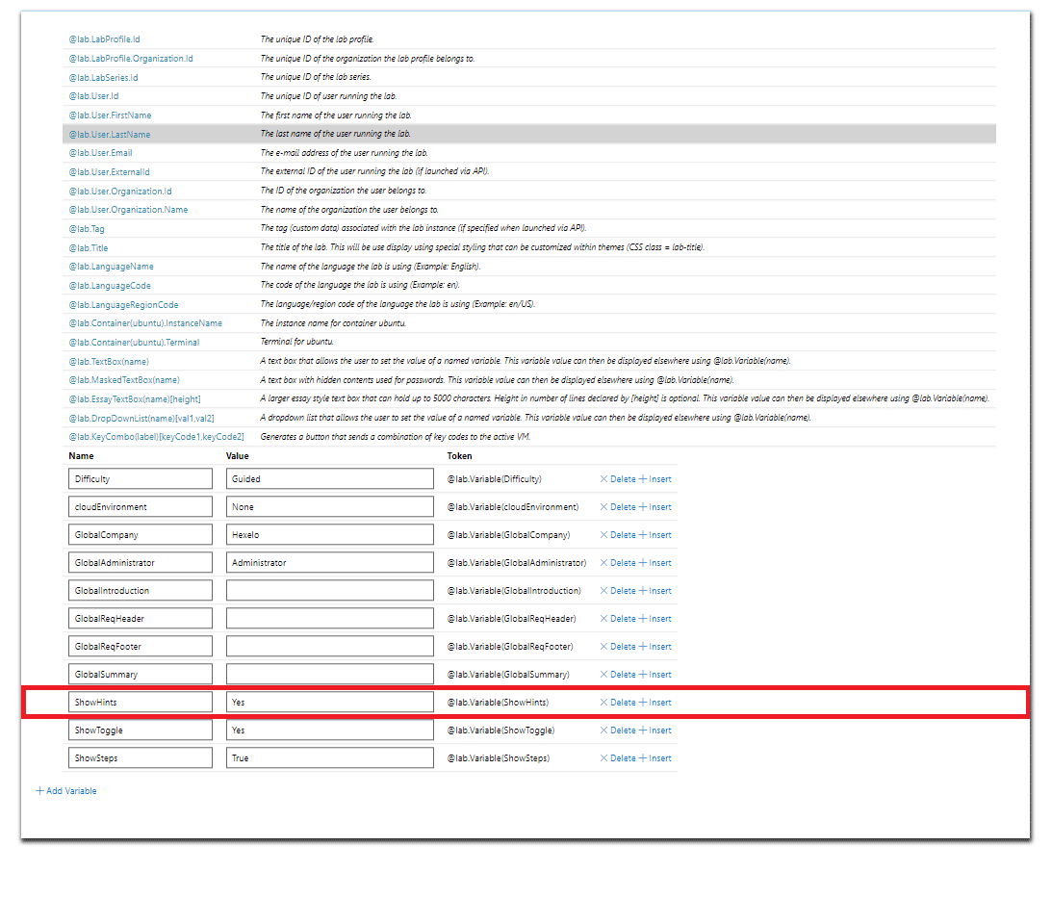

The lab **variables** tab with the **ShowHints** variable highlighted in **red**.

The **ShowHints** variable is turned **OFF (No)** by default. The ShowHints variable allows the author to either hide or display Hints within a Challenge Lab.

In most use cases, Guided and Advanced Challenge Labs would have a value of

**Yes,** while Expert Challenge Labs would have a ShowHints value of **No.**

On the variables page, enter a value of **No** for the **ShowHints** variable, and then select **Tab** to advance to the **ShowToggle** variable.

**CONTINUE**

#### Step 10: Set the Challenge Lab to the Hints Toggle

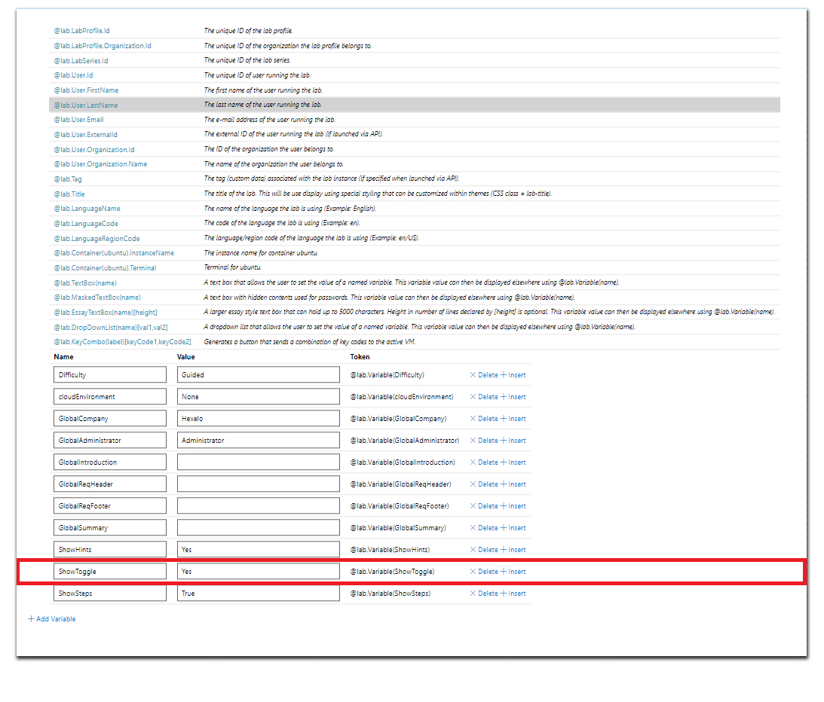

The lab **variables** tab with the **ShowToggle** variable highlighted in **red**.

The **ShowToggle** variable is turned **ON (Yes)** by default. The ShowToggle variable allows the author to make the Toggle either hidden or visible. The Toggle allows a User to either display, or hide Hints, if the Challenge Lab level supports them.

Depending on which level Challenge Lab you are building, you may or may not wish to display the Toggle. In most use cases, Guided and Advanced Challenge Labs would have a value of Yes, while Expert Challenge Labs would have a ShowHints value of **No**.

On the variables page, enter a value of **Yes** for the

**ShowToggle** variable.

**CONTINUE**

#### Step 10: Select OK to save your Variables

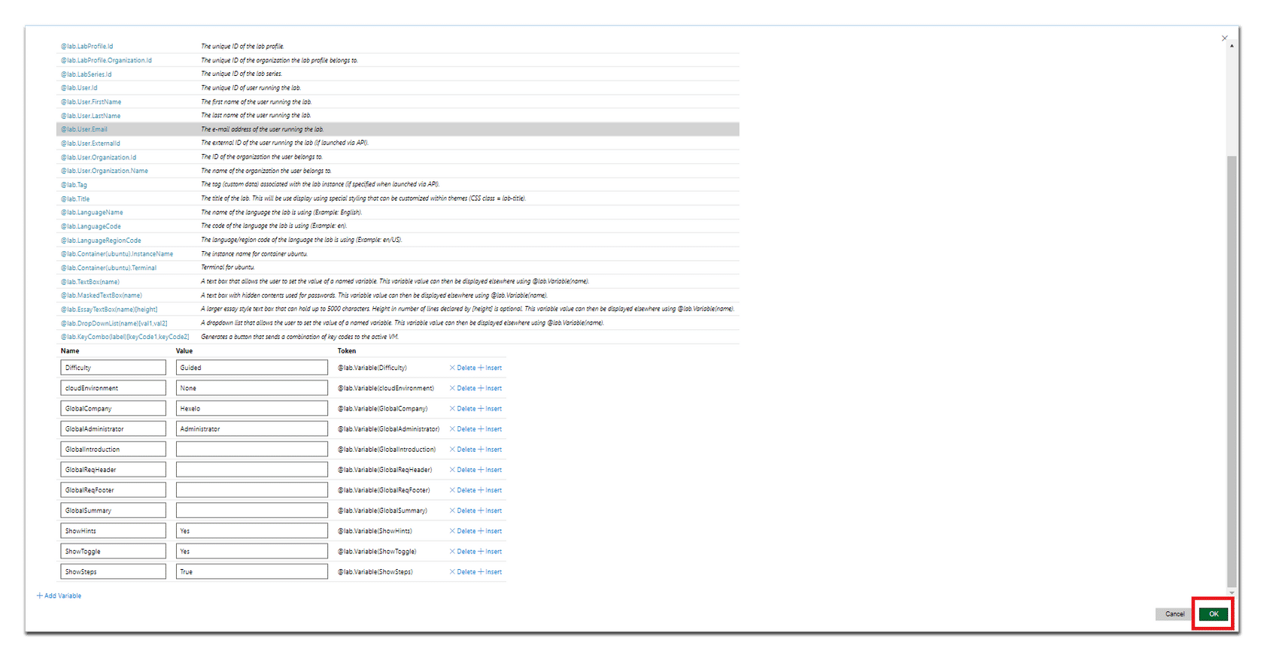

The lab **variables** tab with the **OK button** variable highlighted in **red**.

In the lower-right corner of the Variables tab, select **OK** to save your variable values, and then return to the **Edit Instructions** screen.

**CONTINUE**

*Lesson 9 of 25*

# ADDING VERIFICATION SCRIPTS TO A CHALLENGE LAB

 **Michael Kemper**

#### Creating Your Challenge Lab Scripts

The following step-by-step instructions should help guide you through the process of adding veriﬁcation Scripts to your Challenge Labs.

#### The Lab Proﬁle Page



From the Lab Proﬁle page, you are able to edit the Challenge Lab proﬁle settings and instructions, view the lab manual, and/or launch the Challenge Lab.

**CONTINUE**

#### Step 1: Select Edit Instructions



The Lab Proﬁle page with the **Edit Instructions** button highlighted in **red**.

Select **Edit Instructions** from the Lab Proﬁle page to access the

**Edit Instructions** page.

*Note: If you are already in the Edit Instructions window, proceed to the next step.*

#### The Edit Instructions Window



The Edit Instructions page with the iDLX editor and markdown script on the left, and lab manual visible on the right.

**CONTINUE**

#### Step 2: Select the Activities Button (lightening bolt icon).

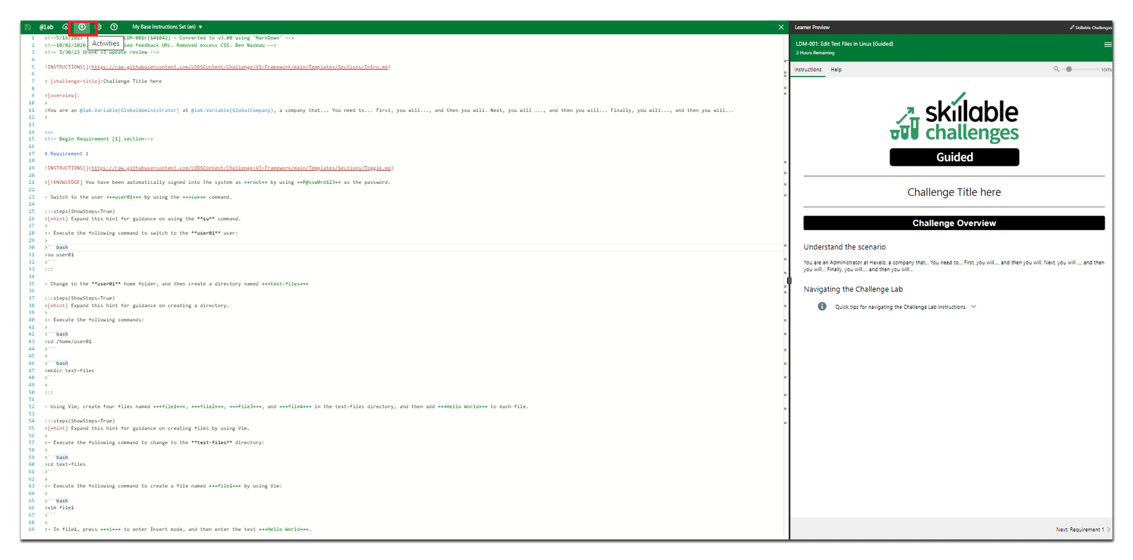

The **Add Lab Variables** button highlighted in **red** in the upper left corner of the

**EditInstructions** page.

Select the **Activities** icon located in the upper left-hand corner of the Edit Instructions window to access the **Activities** page.

**CONTINUE**

#### The Activities Window

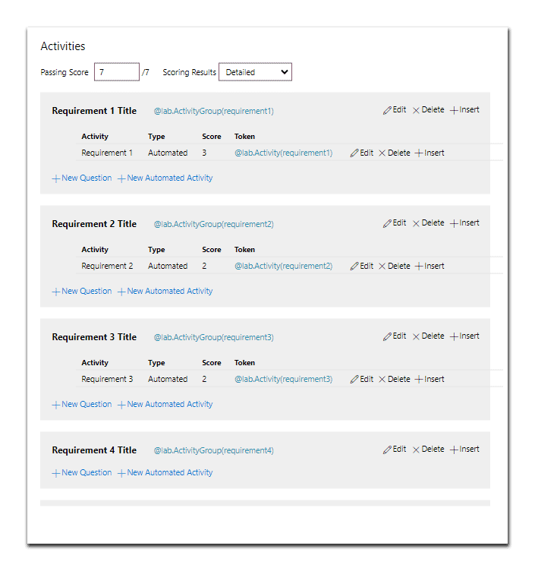

The **Activities** panel allows an author to create veriﬁcation scripts and group them.

This is how a learner is scored.

#### Step 4: Set the Passing Score

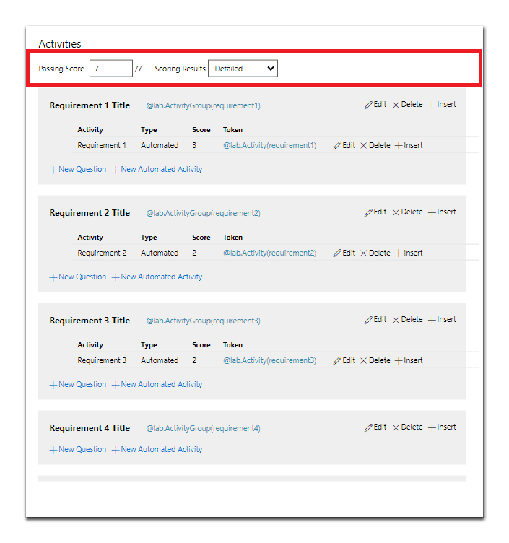

The **Passing Score** textbox displaying a score of 7/8, highlighted in **red**.

On the **Activities** page, in the **Passing Score** textbox, enter a value that calculates to a minimum of **80%**.



**The passing score should be calculated so that the learner must achieve a minimum score of 80% to successfully receive credit for the Challenge Lab.**

**CONTINUE**

#### Activity Groups

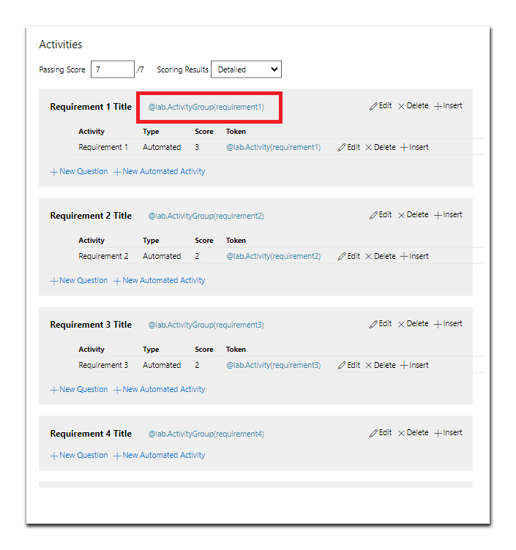

The **Activities** page with the **@lab.ActivityGroup(requirement1) Activity Group**

highlighted in **red**.

Activity groups are containers for Lab Activities (veriﬁcation scripts).



All **Lab Activities** (veriﬁcation scripts) **must** reside within an **Activity Group**.

#### Activities (veriﬁcation scripts)

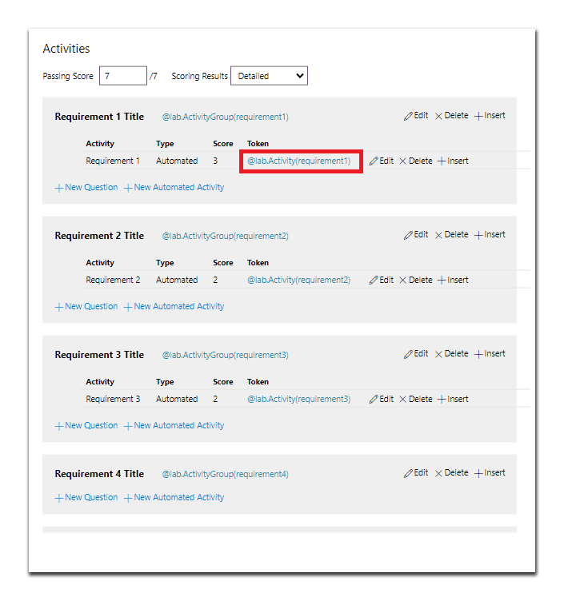

The **Activities** page with the **@lab.Activity(requirement1) Activity Group** highlighted in **red**.



All **Lab Activities** (veriﬁcation scripts) **must** reside within an **Activity Group**.

#### Step 5: Add a New Activity Group

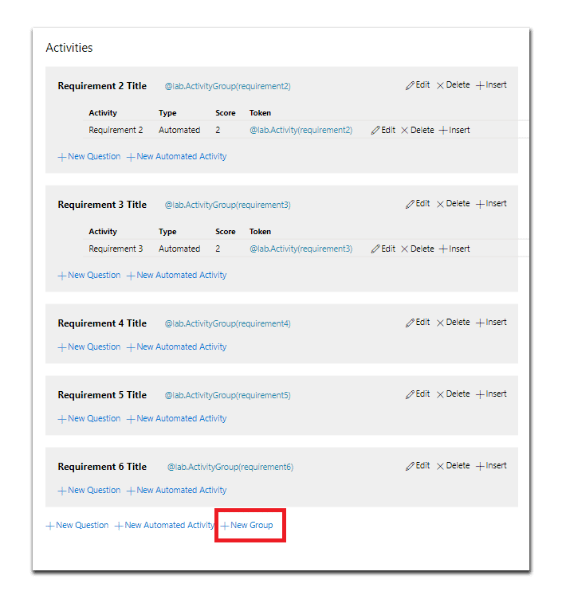

The **Activities** page with the **New Group** button highlighted in **red**.

On the **Activities** page, select **+ New Group** to create a new

**Activity Group**.

**CONTINUE**

#### Step 6: Name the New Activity Group and Token

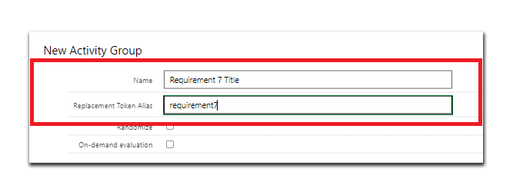

The **Edit Activity Group** page with the **Name** and **Replacement Token Alias**

highlighted in **red**.

On the Edit Activity Group page, in the **Name** textbox, enter

**Requirement 1 Title**.

In the **Replacement Token Alias** textbox, enter **Requirement1**, and then select **Save**.

On the Activities page, verify the new **Activity Group** has been created.

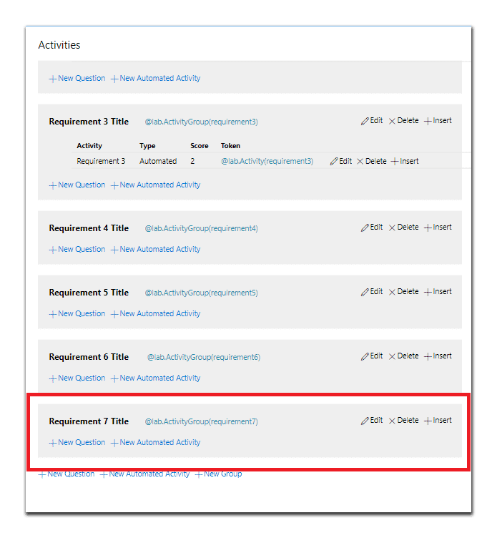

The **Activities** page with the **New Activity Group** highlighted in **red**.

**CONTINUE**

#### Step 7: Create a New Automated Activity (veriﬁcation script)

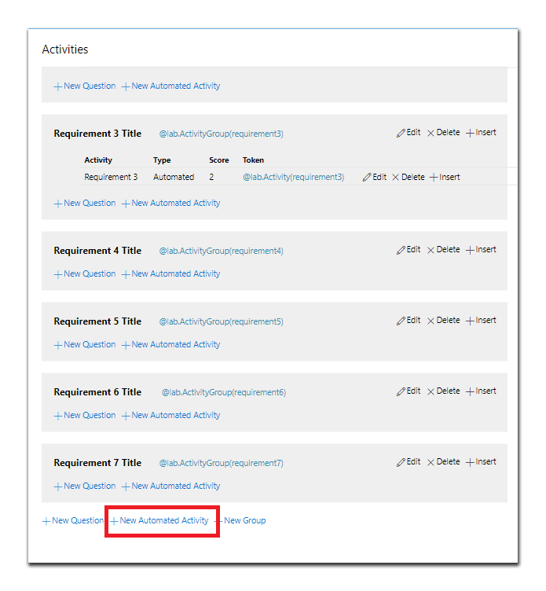

The **Activities** page with **New Automated Activity** highlighted in **red**.

****On the Activities page, in the Requirement 7 Title Activity group, select **New Automated Activity**, to open the **New Automated**

**Activity** window.



A New Automated Activity can also be created and added separately to an Activity Group.

**CONTINUE**

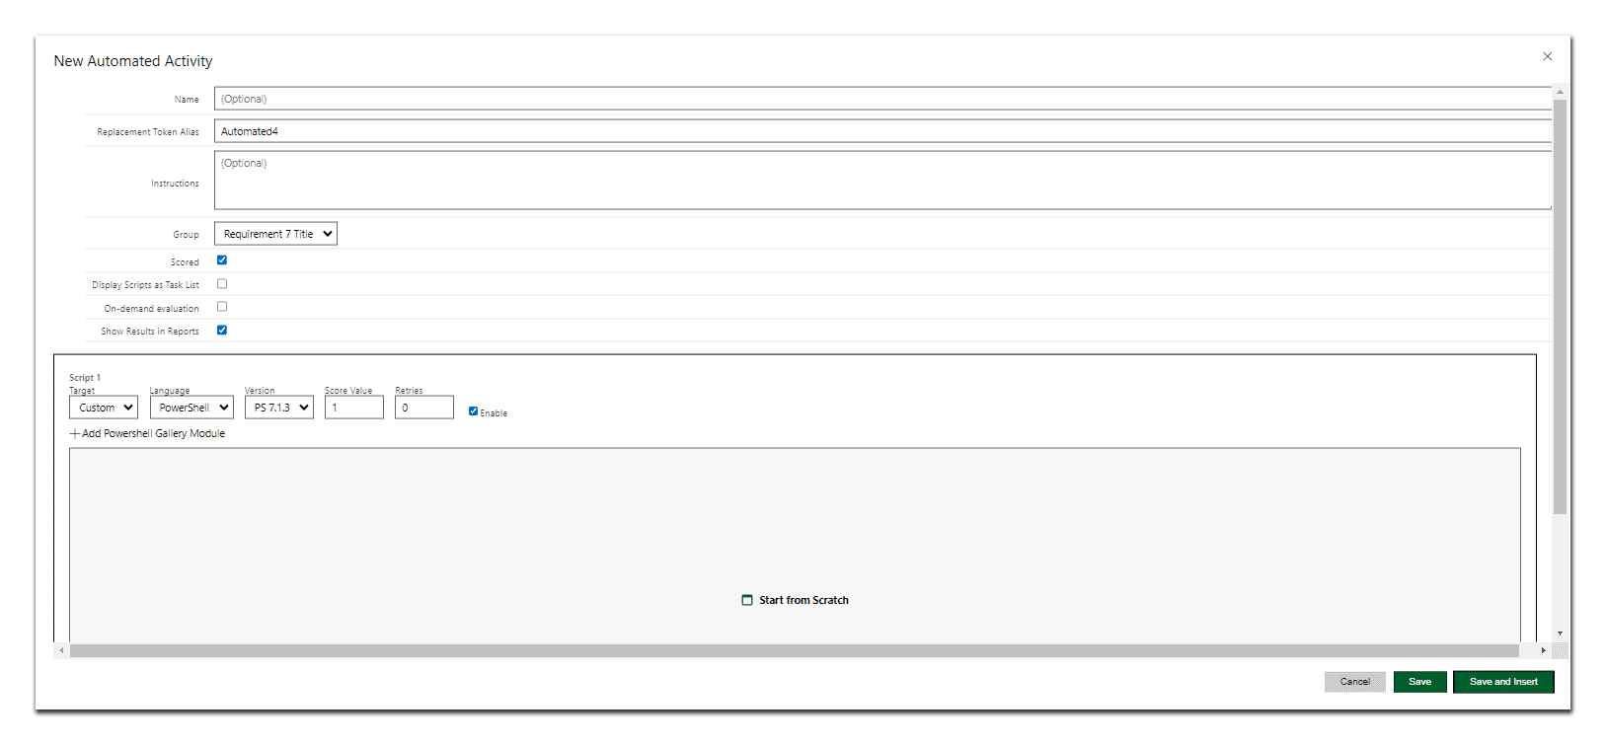

The **New Automated Activity** page.

#### Create a New Automated Activity in the New Activity Group.

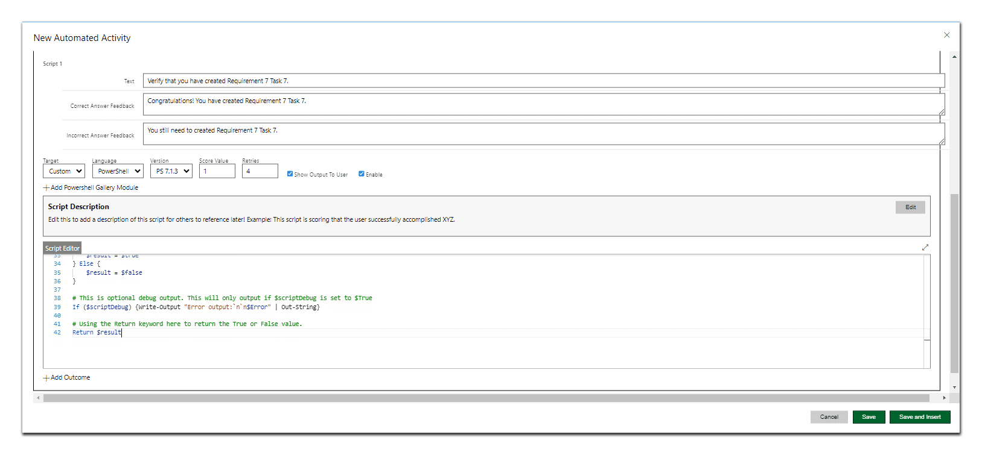

The **Edit Automated Activity** page with values populated.

#### Step 8: Name the New Automated Activity

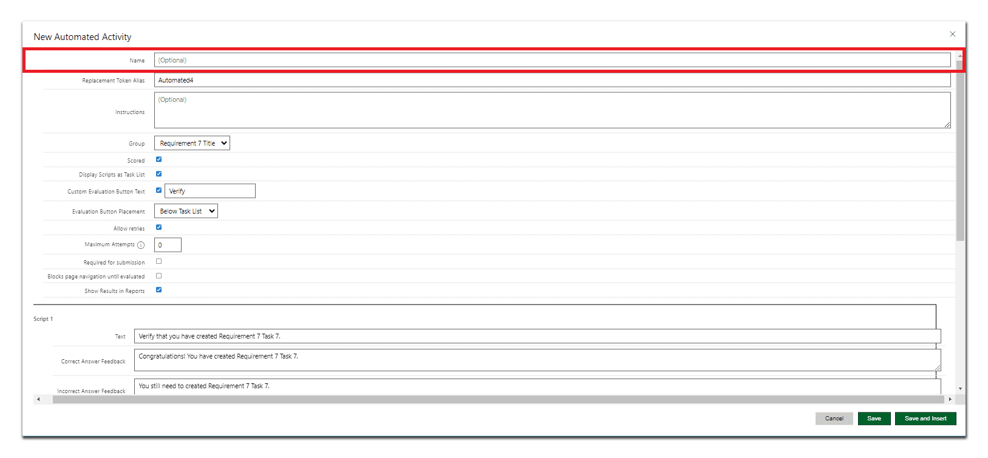

The **Edit Automated Activity** page with **Name** textbox highlighted in **red**.

On the **Edit Automated Activity** page, in the **Name** textbox, enter

**Requirement 7**.

**CONTINUE**

#### Step 9: Edit the Replacement Token Alias

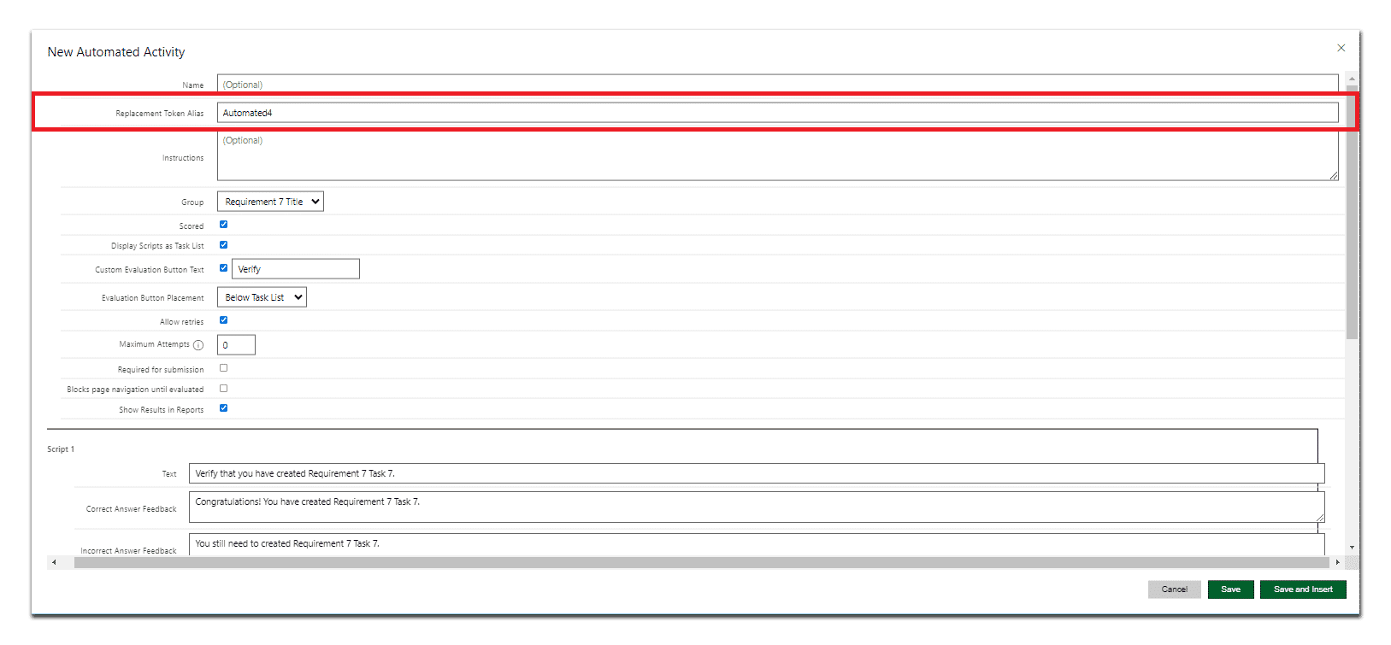

The **Edit Automated Activity** page with the **Replacement Token Alias** highlighted in

**red**.

In the **Replacement Token Alias** textbox, enter **requirement7**.

**CONTINUE**

#### Step 10: Set the Activity Group

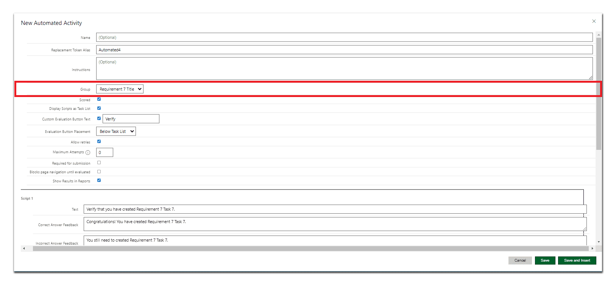

The **Edit Automated Activity** page with the **Group** highlighted in **red**.

In the **Group** dropdown menu, select **Requirement 7 title**.



Since we created the New Activity within a Group, we do not need to change this value. If we had created the new Activity outside of group, we would add it here. Additionally, you can change the Activity Group if needed.

**CONTINUE**

#### Step 11: Enabling Scoring, Displaying Scripts, and Adding Custom Button Text

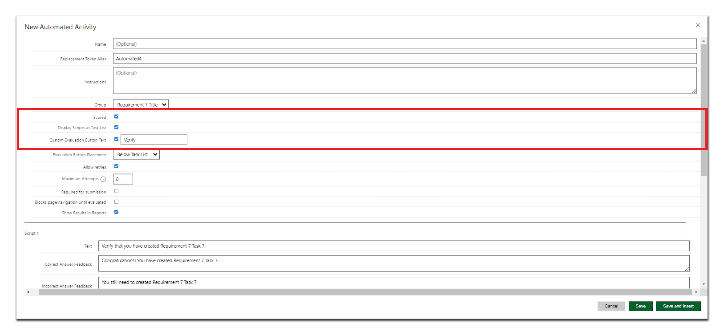

The **Edit Automated Activity** page with the **Scored, Display Scripts as Task List,** and

**Custom Evaluation Button Text** highlighted in **red**.

Verify that **Scored** is **selected**.

Verify that **Display Scripts as Task List** is **selected**.

Verify that **Custom Evaluation Button Text** is **selected**, and then in the textbox enter **Verify**.

**CONTINUE**

#### Step 12: Setting Button Placement, Retries, and Showing Results

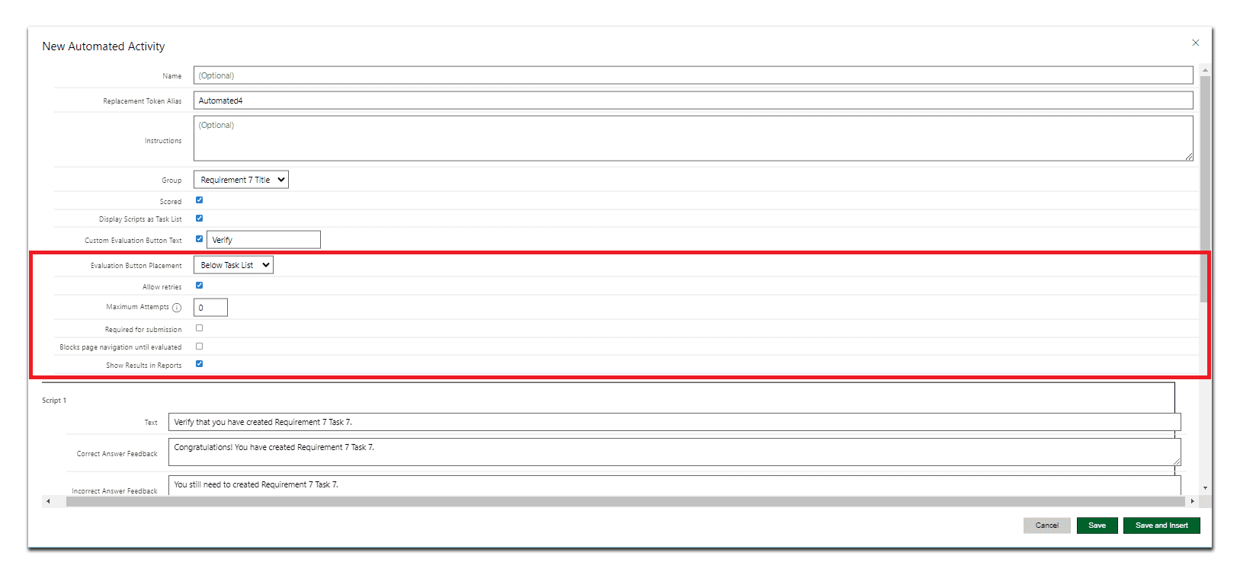

The **Edit Automated Activity** page with the **Evaluation Button Placement, Allow Retries,** and **Show Results in Reports** highlighted in **red**.

In **Evaluation Button Placement,** select **Below Task List** from the dropdown menu box.

Verify that **Allow retries** is **selected**.

Verify that **Maximum Attempts** has a value of **0**.

Verify that **Required for submission** is **deselected**.

Verify that **Blocks page navigation until evaluated** is **deselected**.

Verify that **Show Results in Reports** is **selected**.

**CONTINUE**

#### Creating Script 1

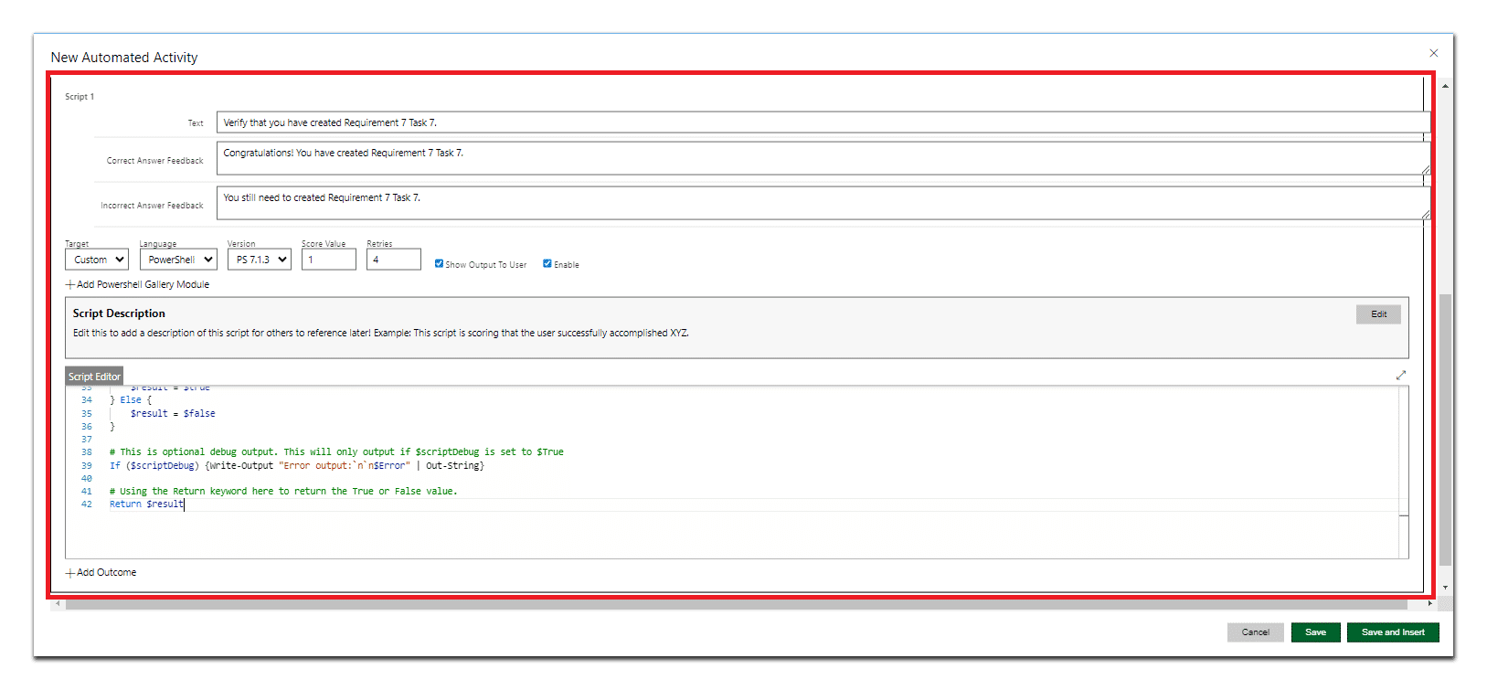

The **Edit Automated Activity** page with **Script 1** highlighted in **red**.

#### Step 13: Editing the Script 1 Text

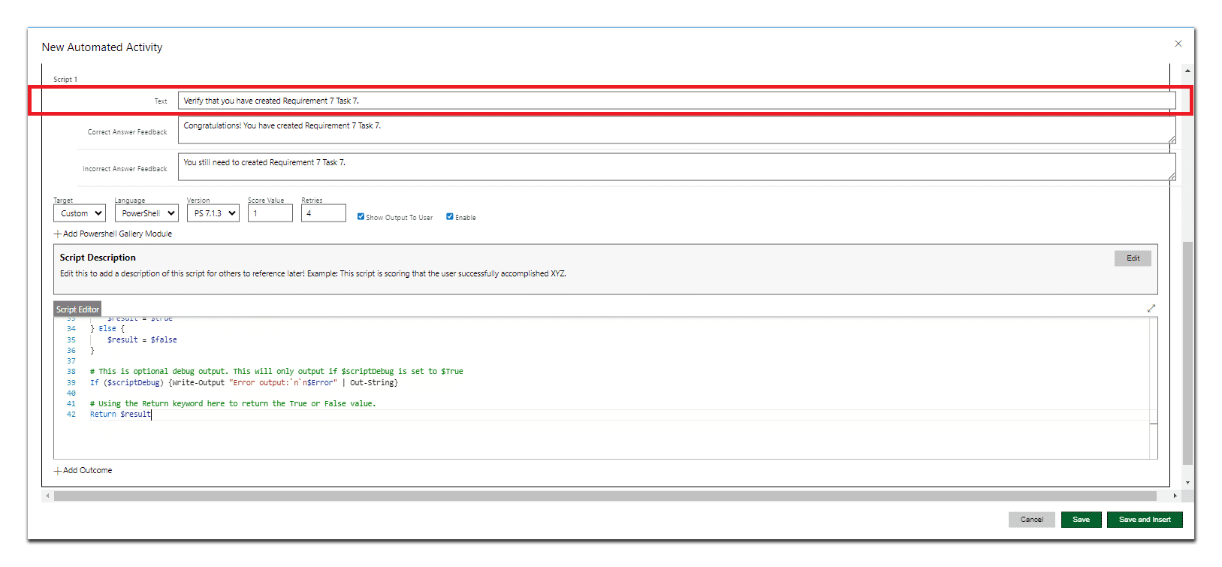

The **Edit Automated Activity** page with the **Script 1 text** highlighted in **red**.

In Script 1, in the **Text** textbox, enter **Verify that you have created Requirement 7 Task 7**.

**CONTINUE**

#### Step 14: Editing the Correct Answer Feedback

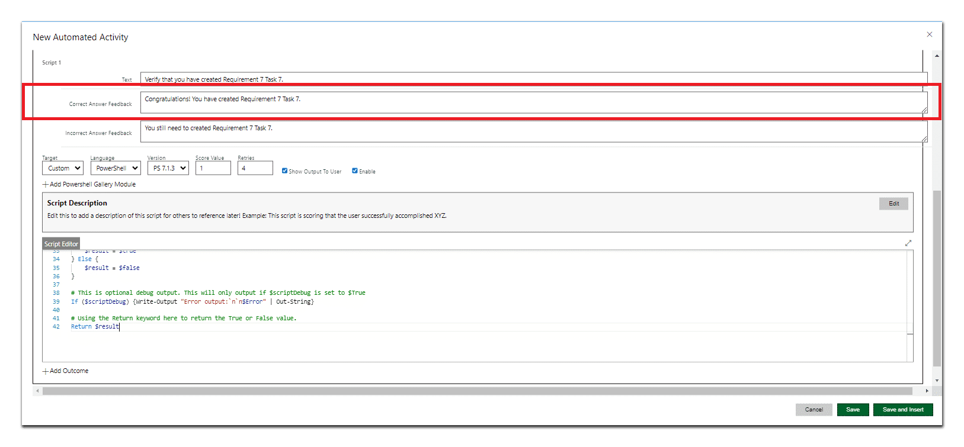

The **Edit Automated Activity** page with the **Correct Answer Feedback** highlighted in

**red**.

****In the **Correct Answer Feedback** textbox, enter **Congratulations! You have created Requirement 7 Task 7.**

**CONTINUE**

#### Step 15: Editing the Incorrect Answer Feedback

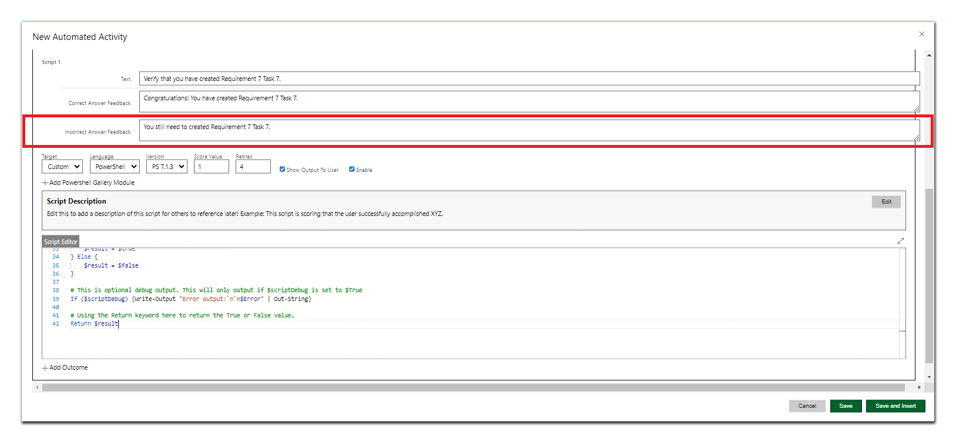

The **Edit Automated Activity** page with the **Incorrect Answer Feedback** highlighted in

**red**.

****In the **Incorrect Answer Feedback** textbox, enter **You still need to create Requirement 7 Task 7.**

**CONTINUE**

#### Step 16: Set the Target, Language, Version, Score Value, and Retries

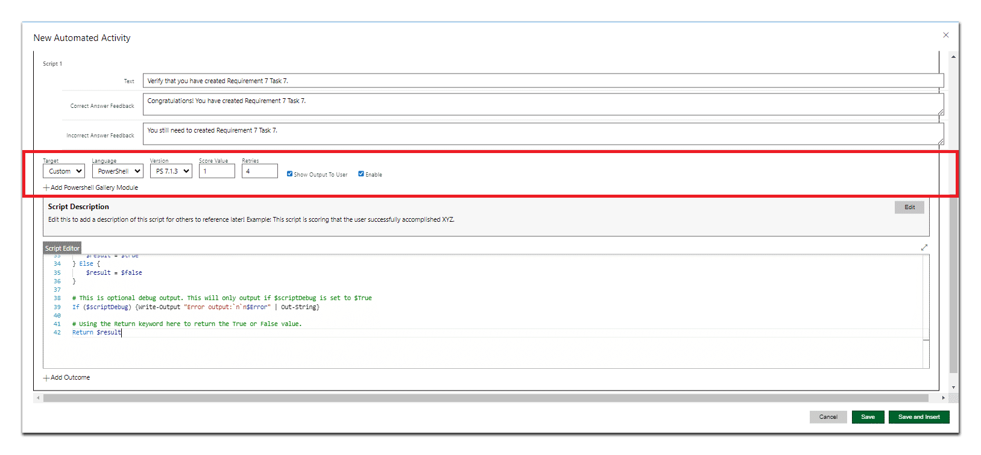

The **Target, Language, Version, Score Value,** and **Retries** page with the **Incorrect Answer Feedback** highlighted in **red**.

In Target**,** select **Custom** from the dropdown menu box.

In **Language,** select **Powershell** from the dropdown menu box.

In **Version,** select **PS 7.1.3** from the dropdown menu box.

****In the **Score Value** textbox, enter **1.**

****In the **Retries** textbox, enter **4.**

Verify that **Show Output To User** is **selected**.

Verify that **Enable** is **selected**.

**CONTINUE**

#### Step 18: Add the Script

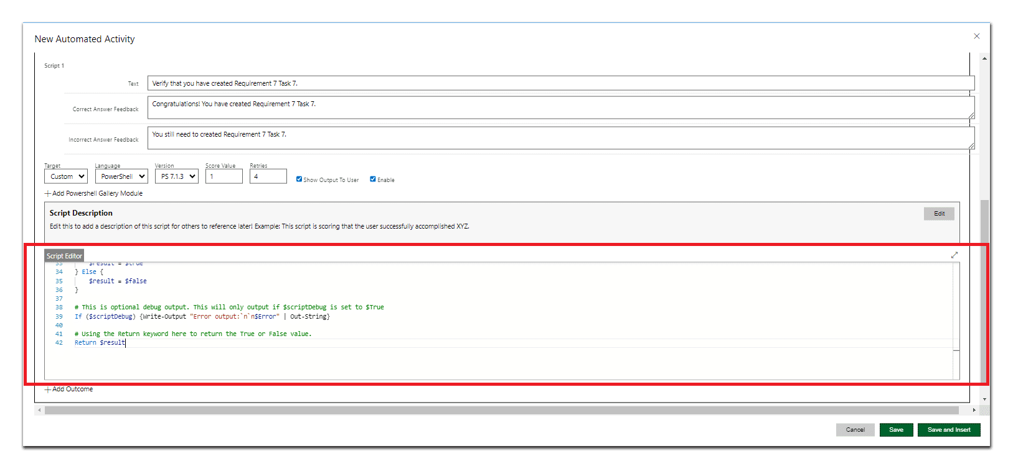

The **Edit Automated Activity** page with the **Script** highlighted in **red**.

In the Script 1, below **+Add Powershell GalleryModule**, enter the Activity to Script 1, and then select **Save**.

**CONTINUE**

*Lesson 10 of 25*

# ALERT BLOCKS

 **Michael Kemper**

### Use an alert to warn learners to take care when performing a task if the outcome of the task might impact the results later in the Challenge Lab. Use these sparingly!

#### Lab Manual View

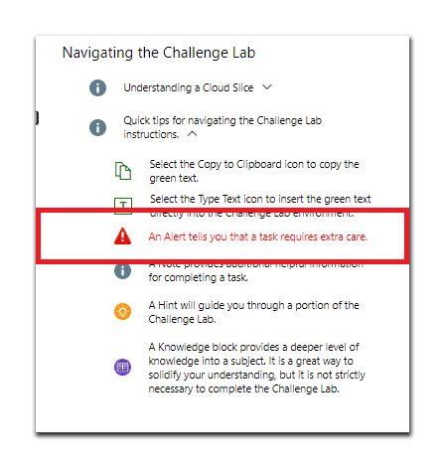

The **Lab Manual** with an **Alert block** highlighted in **red**.

#### iDLX Editor View

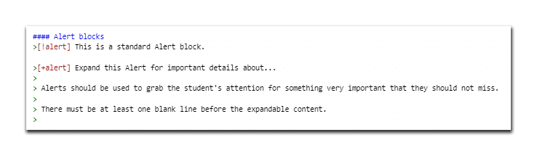

The **iDLX editor** with **Alert block** markdown, highlighted in **red**.

**Copy the below markdown to create an Alert block:**



#### Alert blocks

>[!alert] This is a standard Alert block.

>[+alert] Expand this Alert for important details about...

>

* Alerts should be used to grab the student's attention for something very important that they should not miss.

>

* There must be at least one blank line before the expandable content.

#### Example of an Alert block

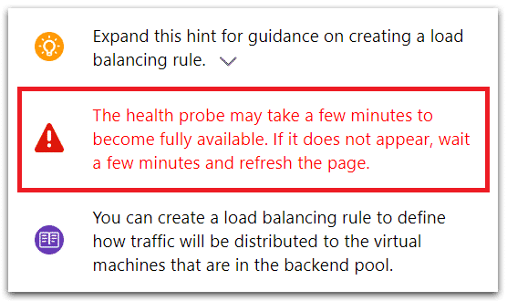

The **Lab Manual** with an **Alert block** highlighted in **red**.

#### Creating an Alert block

**In the iDLX editor, locate the Alert markdown. The markdown should look like the following:**

1

**>[!alert] This is a standard Alert block.**

**>[+alert] Expand this Alert for important details about...**

**>**

* **Alerts should be used to grab the student's attention for something very important that they should not miss.**
* **There must be at least one blank line before the expandable content.**

Select the **Brief description of alert.** text, and then replace it with the **new alert text**.

2

Repeat the above steps to add additional **Alert blocks**.

3

#### Additional Information

In alerts, avoid the use of bold formatting. If you need to call out a speciﬁc item, use italics.

An alert should be indented at the same level as the item that preceded it.

**CONTINUE**

*Lesson 11 of 25*

# CODE BLOCKS

 **Michael Kemper**

#### Lab Manual View

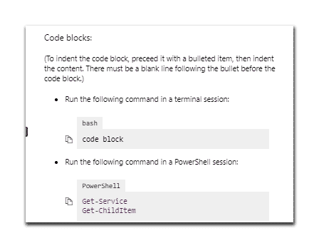

The **Lab Manual** with a **Code block**.

#### iDLX Editor View

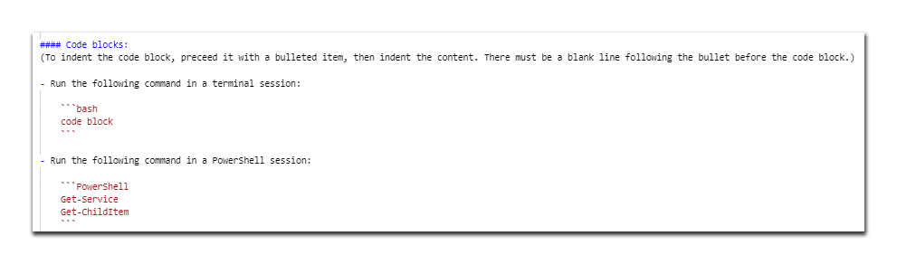

The **iDLX editor** with **Code block** markdown.

**Copy the below markdown to create a Code block:**



**```PowerShell Get-Service Get-ChildItem**

**```**

#### Example of a Code block

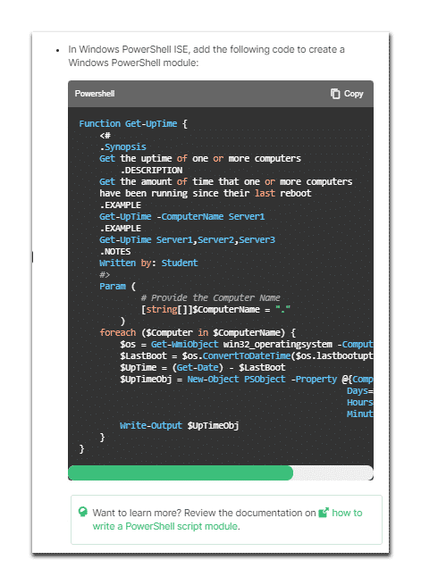

The **Lab Manual** with a **Code block** highlighted in **red**.

#### Creating a Code block

**In the iDLX editor, locate the Code Block markdown. The markdown should look like the following:**

1

**```bash**

**code block**

**```**

**- Run the following command in a PowerShell session:**

**```PowerShell**

**Get-Service**

**Get-ChildItem**

**```**

Select the **code block** text, and then replace it with the **new code block text**.

2

Repeat the above steps to add additional **Code blocks**.

3

#### Additional Information

Code that contains quotation marks should be placed in a fenced code block or should use the Copy to clipboard or Type Text features.

**CONTINUE**

*Lesson 12 of 25*

# COPY TEXT / TYPE TEXT

 **Michael Kemper**

### Everything that you want a learner to enter into a text box, a conﬁguration setting, or a code window should be conﬁgured to use copyable text. This saves time for learners, prevents typing errors, and allows learners to focus on the learning concepts of your lab rather than on entering text.



There are two available options for copyable text: Copy to clipboard and Type Text. The markdown syntax and the display of the two options is slightly diﬀerent, but the beneﬁt to the learner is the same.

#### Lab Manual View

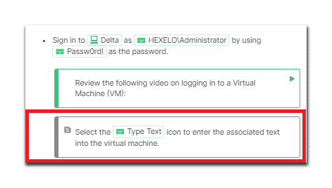

The **Lab Manual** with **Copy to clipboard / Markdown** text.

#### iDLX Editor View

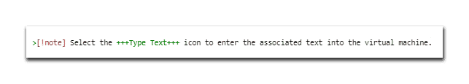

The **iDLX editor** with **Copy to clipboard / Type text** markdown.

**Copy the below markdown to create Copy to clipboard / Type text:**



**>[!note] Select the +++Type Text+++ icon to enter the associated text into the virtual machine.**

#### Example of Copy to clipboard / Type text

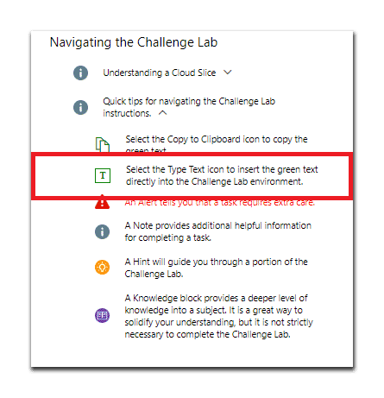

The **Lab Manual** with **Copy to clipboard / Type text** highlighted in **red**.

#### Creating Copy to Clipboard / Type Text

In the iDLX editor, locate the Copy to clipboard markdown. The markdown should look like the following:

1

**>[!note] Select the +++Type Text+++ icon to enter the associated text into the virtual machine.**

Select the text which you wish to convert to Copy to clipboard / Type Text/

2

Place "**++**" directly before and after the text.

3

Repeat the above steps to create additional Copy to clipboard / Type text/

4

Use the following phrases as a tip the ﬁrst time you use copyable text in your Challenge Lab instructions:

**Select the Copy to clipboard icon to copy the text string to the clipboard.**

 **Select the Type Text icon to enter the associated text into the virtual machine.**

#### Additional Information

The **Copy to clipboard** feature in the markdown allows you to deﬁne text or code items that a learner can copy from the instructions and paste into a web browser in the lab environment.

To use the **Copy to clipboard** feature, surround the copyable text with two **+** signs.

The **Type Text** feature in the markdown is used in a virtual machine environment and allows a learner to enter text or code items directly into a virtual machine.

To use the **Type Text** feature, surround the copyable text with three **+** signs.

When working with the **Copy to clipboard** and **Type Text** features, ensure that there is no space between the **+** signs and the text contained between them.

**Copyable text** can contain a **+** sign.

In instructional text, when you want the learner to enter the value, display exactly what the learner should enter, preferably using the **Copy to clipboard** or **Type Text** features.

Use the **Type Text** or **Copy to clipboard** features instead of bold format where possible.

Code that contains quotation marks should be placed in a fenced code block or should use the **Copy to clipboard** or **Type Text** features.

**CONTINUE**

*Lesson 13 of 25*

# FONT FORMATTING

 **Michael Kemper**

### In the IDLx, you only apply **bold** format to UI elements which which a learner interacts. This formatting style is designed with the UI of the Lab on Demand platform in mind. You want to draw the learner's attention to the UI elements with which a learner interacts.

#### Creating Bold Text

In the iDLX editor, locate the markdown which you wish to **bold**.

1

In the markdown, use two asterisks (**) or an underscore on either side of the text to which you want to apply **bold** format.

2

Repeat the above steps to **bold** additional **text**.

3

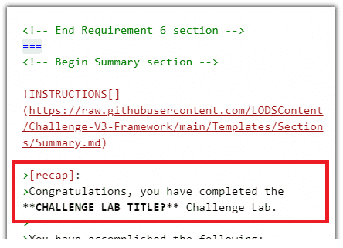

The **iDLX editor** with the **Bolded Challenge Title** highlighted in **red**.

#### Additional Information

**Use Bold:**

For something in the UI that a learner must select.

For something that a learner must verify.

For keys on the keyboard.

In the IDLx, only apply **bold** formatting to UI elements with which a learner interacts.

The settings are all items with which a learner interacts, so they should either use copyable text or **bold** format.

Use **bold** format for the ellipsis, but not the parentheses.

**Do Not Use Bold:**

For labels.

For menus.

For verbs that are part of an instruction but are not part of an instruction to select a UI element.

To call out parts of an instructional sentence that are not something in the UI that a learner must select.

To help identify the location of an item on a page.

****In knowledge blocks, notes, alerts, and tips, avoid the use of **bold**

formatting. If you need to call out a speciﬁc item, use italics.

You don’t need to format the table heading using a bold font format. Table headings are automatically displayed in **bold**.

Row headings do not use **bold** format.



Use Type Text or Copy to clipboard for values that a learner must type.

**CONTINUE**

#### Creating Italic Text

In the iDLX editor, locate the markdown which you wish to

1

***italicize***.

In the markdown, use one asterisk (*) on either side of the text to which you want to apply ***italic*** format.

2

Repeat the above steps to ***italicize*** additional **text**.

3

**CONTINUE**

*Lesson 14 of 25*

# HIDDEN ITEM SECTIONS

 **Michael Kemper**

### **Hidden Item Sections** allow an author to hide additional items such as images and notes, that might not fall within a Hint or by default be hidden.

#### Lab Manual View

You would NOT see a **hidden item section** on the Lab Manual side of a **Challenge Lab**, because it is hidden by default.

#### iDLX Editor View

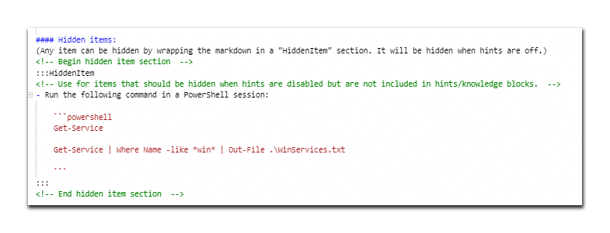

The **iDLX editor** with **Hidden Item Section** markdown.

**Copy the below markdown to create a Hidden Item Section:**



**<!-- Begin hidden item section -->**

**:::hiddenitem**

**<!-- Use for items that should be hidden when hints are disabled that may not be included in hints/note blocks. -->**

- Run the following command in a PowerShell session:

**```powershell Get-Service**

**Get-Service | Where Name -like *win* | Out-File .\WinServices.txt**

**```**

**:::**

**<!-- End hidden item section -->**

#### Creating a Hidden Item Section

In the iDLX editor, locate the Hidden Item Section markdown. The markdown should look like the following:

1

<!-- Begin hidden item section -->

:::hiddenitem

<!-- Use for items that should be hidden when hints are disabled that may not be included in hints/note blocks. -->

```bash code block

```

:::

<!-- End hidden item section -->

Select the text below **:::hiddenitem** and **:::**, and then replace it with the text or image that wish wish to hide.

2

DO NOT REMOVE THE **:::**!

Repeat the above steps to create additional **Hidden Item Sections**.

3

**CONTINUE**

*Lesson 15 of 25*

# HINTS

 **Michael Kemper**

Use a **hint** to provide learners with the details of how to perform the action in the Task.

## Guided Hints

#### Lab Manual View

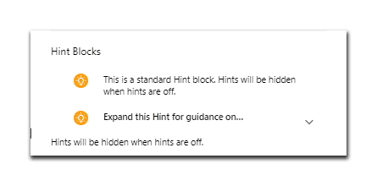

The **Lab Manual** with a **closed Hint** displayed.

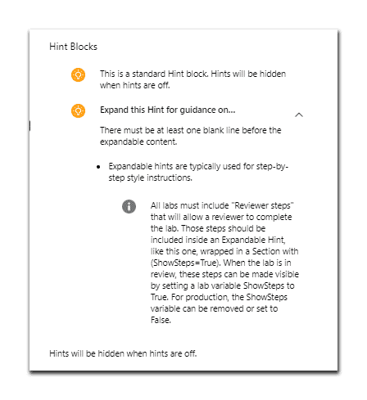

The **Lab Manual** with an **expanded Hint** displayed.

#### iDLX Editor View

Hints are contained in speciﬁc markdown. The summary tag contains a heading that ties the hint to the instructional step.

The heading will always being with the phrase "Expand this hint for guidance on", and you will need to complete the sentence as needed for your hint.

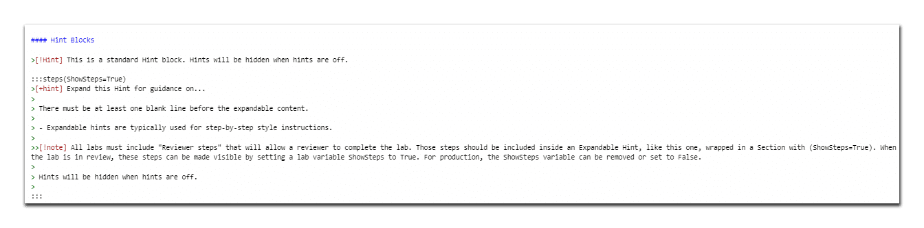

The **iDLX editor** with **Hint** markdown, highlighted in **red**.

**Copy the below markdown to create a Guided Hint:**



>[!Hint] This is a standard Hint block. Hints will be hidden when hints

are oﬀ.

:::steps(ShowSteps=True)

>[+hint] Expand this Hint for guidance on...

>

* There must be at least one blank line before the expandable content.
* - Expandable hints are typically used for step-by-step style

instructions.

>>[!note] All labs must include "Reviewer steps" that will allow a

reviewer to complete the lab. Those steps should be included inside an Expandable Hint, like this one, wrapped in a Section with (ShowSteps=True). When the lab is in review, these steps can be made visible by setting a lab variable ShowSteps to True. For production, the

ShowSteps variable can be removed or set to False.

* Hints will be hidden when hints are oﬀ.

:::

#### Example of a Hint

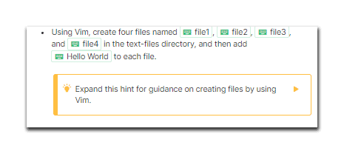

The **Lab Manual** with a **closed Hint** displayed.

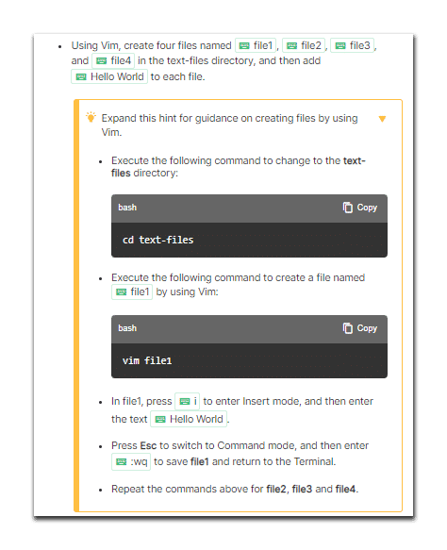

The **Lab Manual** with an **expanded Hint** displayed.

#### Creating a Guided Hint

In the iDLX editor, locate the **Guided**

1

**Hint** markdown. The markdown should look like the following:

**>[!Hint] This is a standard Hint block. Hints will be hidden when hints are of.**

**:::steps(ShowSteps=True)**

**>[+hint] Expand this Hint for guidance on...**

**>**

* **There must be at least one blank line before the expandable content.**
* **- Expandable hints are typically used for step-by-step style instructions.**

**:::**

Select the **...** which directly follows **Expand this hint for guidance on**, and then replace it with the **new guidance text**.

2

Add each step in the Task on it's own line, to the right of the hyphens.

3

Repeat the above steps to add additional **Steps**.

4

Repeat the above steps to add additional **Hints**.

5

#### Additional Information

Hints can contain a video that steps learners through what they need to do to perform the action in the step.

Hints can contain a screenshot that shows the correct conﬁguration and any UI elements the learner must select in order to get to the conﬁguration page

Hints can contain an instructional step that uses the what / where / why structure.

Hints can contain the complete code syntax of any code that’s required.

Each step in a hint should use a ﬁrst level bullet. Because you have a limited screen width, avoid using second level bullets.

**CONTINUE**

## Advanced Hints

#### Lab Manual View

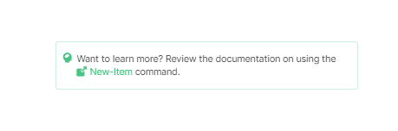

The **Lab Manual** with an Advanced **Hint** displayed.

#### iDLX Editor View

In an Advanced challenge, use a hint to provide more information on how to perform the action in a step; however, unlike Guided challenges, the hint should be in the form of a URL that contains information on how to perform the required action.

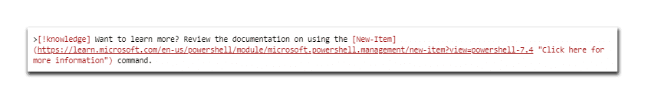

The **iDLX editor** with **Hint** markdown, highlighted in **red**.

**CONTINUE**

*Lesson 16 of 25*

# IMAGES

 **Michael Kemper**

## Adding Screen Captures

The following step-by-step instructions will help guide you through the process of adding images to a Challenge Lab.

#### The Lab Proﬁle Page



From the Lab Proﬁle page, you are able to edit the Challenge Lab proﬁle settings and instructions, view the lab manual, and/or launch the Challenge Lab.

**CONTINUE**

#### Step 1: Select Edit Instructions



The Lab Proﬁle page with the Edit Instructions button highlighted in **red**.

Select **Edit Instructions** from the Lab Proﬁle page to access the Edit Instructions page.

#### The Edit Instructions Window



The Edit Instructions window with the iDLX editor and markdown script on the left, and lab manual visible on the right.

**CONTINUE**

#### Step 2: Select Upload File (the Cloud icon)

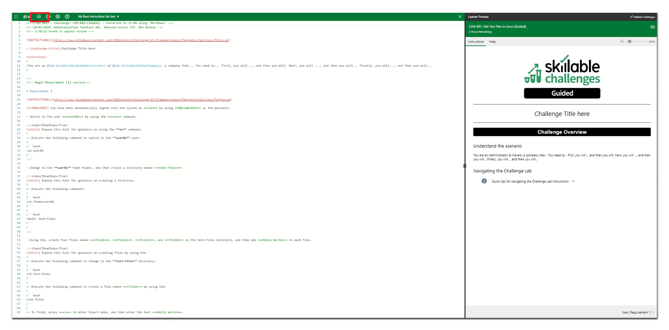

The Upload File button highlighted in **red** in the upper left corner of the Edit Instructions window.

Select the **Upload Image** icon located in the upper left-hand corner of the Edit Instructions window to access the **Upload Files** window.

#### The Upload Image Window

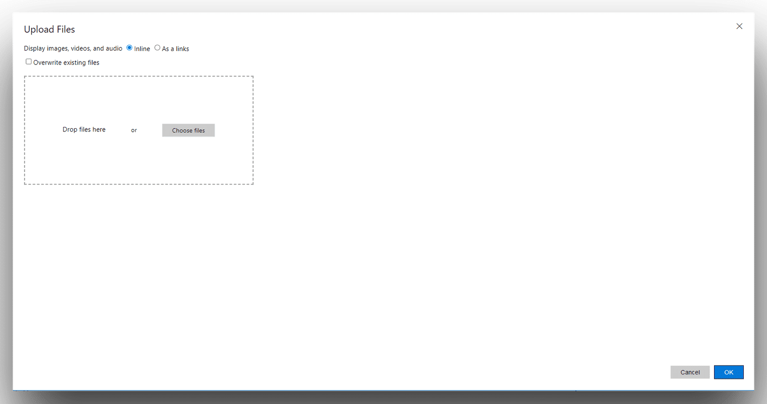

Once you select the **Upload Files** icon, the Upload Files window opens.

#### Step 3: Select the Variables Tab

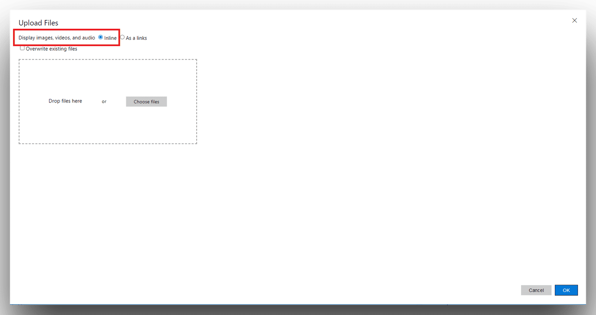

**Display images, videos, and audio** highlighted in **red** in the upper left corner of the Upload Files window.

On the Upload Files page, in Display images, **videos**, and **audio**, select **Inline**.

**CONTINUE**

#### Step 4: Choose The Image File

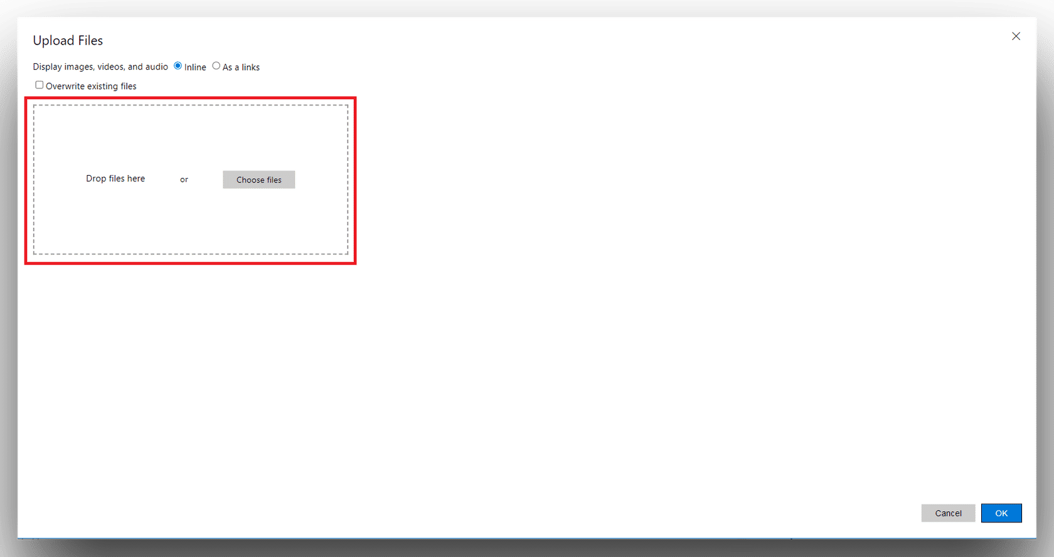

**Drop ﬁles here** highlighted in **red** in the upper left corner of the **Upload Files** window.

#### Print Screen Method

Locate the image you wish to use in the new Challenge Lab.

Select the **Print Screen** button located on your keyboard.

Determine where you want the image to appear in your Challenge Lab, and then paste the image you just captured.

Your new image is now visible in the Lab Manual portion of the Challenge Lab.



You may need an image editing program such as Paint, to crop your images as the Upload Image window does not support that functionality.

#### Upload Method

Determine where you want the new image to appear in your Challenge Lab.

Locate the **image** you wish to use in the new Challenge Lab.

Open the **Upload Files** icon from the Edit Instructions window.

On the Upload Files window, select the **Choose ﬁles** button, and then navigate to the ﬁle you wish to upload.

Select the **image**, and then select **Open**.

On the **Upload Files** window, select **OK**.

Your new image can is now visible in the Lab Manual portion of the Challenge Lab.

**CONTINUE**

*Lesson 17 of 25*

# KNOWLEDGE BLOCKS

 **Michael Kemper**

### Use a **knowledge block** if you have additional information that you want to convey to learners. This provides a visual separation between your instructional step and the additional information.

#### Lab Manual View

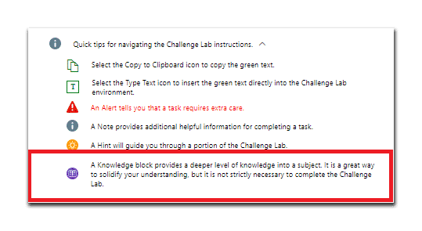

The **Lab Manual** with an **Alert block** highlighted in **red**.

#### iDLX Editor View

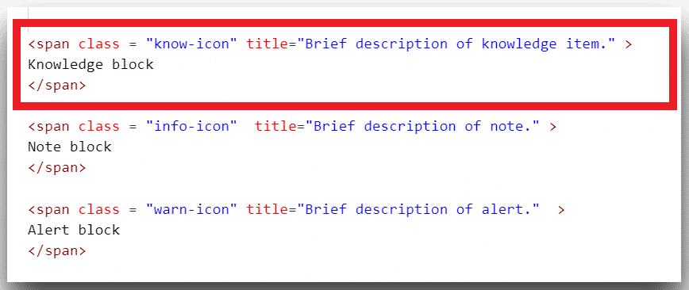

The **iDLX editor** with **Knowledge block** markdown, highlighted in **red**.

**Copy the below markdown to create a Knowledge block:**



**<span class = "know-icon" title="Brief description of knowledge item."**

**Knowledge block**

**</span>**

#### Example of a Knowledge block

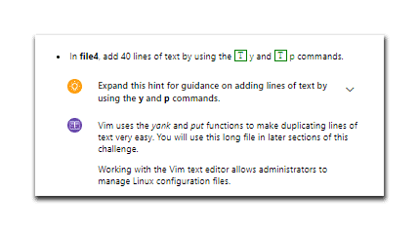

The **Lab Manual** with a **Knowledge block** highlighted in **red**.

#### Creating a Knowledge block

In the iDLX editor, locate the Knowledge Block markdown. The markdown should look like the following:

1

**<span class = "know-icon" title="Brief description of knowledge item."> Knowledge block**

**</span>**

Select the **Brief description of knowledge item** text, and then replace it with the **new Knowledge Block text**.

2

Repeat the above steps to add additional **Knowledge blocks**.

3

#### Additional Information

Add knowledge blocks to provide additional context.

In knowledge blocks, avoid the use of bold formatting. If you need to call out a speciﬁc item, use italics.

Don't use images in knowledge blocks — place the image in a note instead. Learners need to expand knowledge blocks in order to see more than the ﬁrst few lines of content, so they may not see your image.

Use a knowledge block to provide a deeper level of knowledge than can be explained in an instruction step.

A knowledge block should be indented at the same level as the item that preceded it.

**CONTINUE**

*Lesson 18 of 25*

# NOTES

 **Michael Kemper**

### **Notes** are similar to knowledge blocks. Use a note to convey information about the Getting Started lab or Challenge Lab and the lab environment rather than about the technology in the Getting Started lab or challenge lab.

#### Lab Manual View

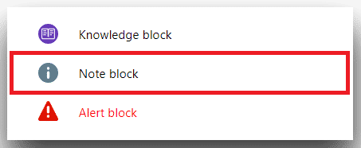

The **Lab Manual** with an **Note block** highlighted in **red**.

#### iDLX Editor View

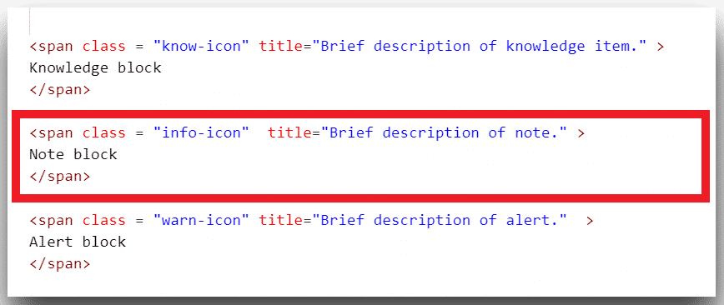

The **iDLX editor** with **Note block** markdown, highlighted in **red**.

**Copy the below markdown to create a Note block:**



**<span class = "info-icon" title="Brief description of note." > Note block**

**</span>**

#### Example of a Note block

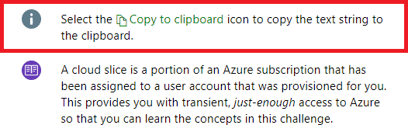

The **Lab Manual** with a **Note block** highlighted in **red**.

#### Creating a Note block

In the iDLX editor, locate the Note Block markdown. The markdown should look like the following:

1

**<span class = "info-icon" title="Brief description of note." >**

**Note block**

**</span>**

Select the **Brief description of note** text, and then replace it with the **new Note Block text**.

2

Repeat the above steps to add additional **Note blocks**.

3

#### Additional Information

Add **Note blocks** to provide additional context.

In **Note blocks**, avoid the use of **bold formatting**. If you need to call out a speciﬁc item, use *italics*.

When you use learning features like **Notes** between steps in a bulleted list, you must indent each learning item four spaces in order to match the indentation of the bullet.

Don't use images in knowledge blocks — place the image in a **Note** instead. Learners need to expand knowledge blocks in order to see more than the ﬁrst few lines of content, so they may not see your image.

A **Note block** should be indented at the same level as the item that preceded it.

**CONTINUE**

*Lesson 19 of 25*

# TABLES

 **Michael Kemper**

### When you want a learner to conﬁgure settings or properties, consider using a **table**. **Tables** allow you to display a lot of relevant information in once place without the need to write an instructional step for each setting.

#### Lab Manual View

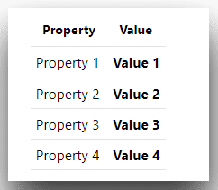

The **Lab Manual** with a **Table** highlighted in **red**.

#### iDLX Editor View

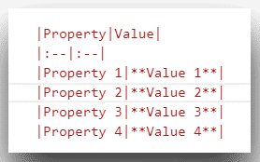

The **iDLX editor** with **Table** markdown, highlighted in **red**.

**Copy the below markdown to create a Table:**



**|Property|Value|**

**|:--|:--|**

**|Property 1|**Value 1**|**

**|Property 2|**Value 2**|**

**|Property 3|**Value 3**|**

**|Property 4|**Value 4**|**

#### Example of a Table

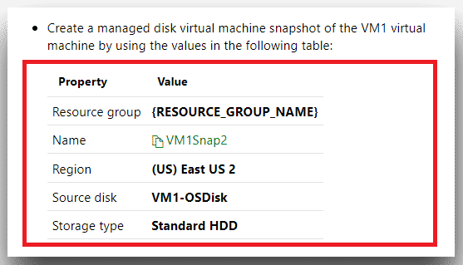

The **Lab Manual** with a **Table** highlighted in **red**.

#### Creating a Table

In the iDLX editor, locate the Table markdown. The markdown should look like the following:

1

**|Property|Value|**

**|:--|:--|**

**|Property 1|**Value 1**|**

**|Property 2|**Value 2**|**

**|Property 3|**Value 3**|**

**|Property 4|**Value 4**|**

Select the **Property 1** text, and then replace it with the **new Property 1 text**.

2

Select the **Value 1** text, and then replace it with the **new Value 1 text**.

3

Repeat steps 2 and 3 until all Properties and Values have been entered.

4

Repeat the above steps to add additional **Tables**.

5

#### Additional Information

The most commonly used table display is a two-column table that contains left-aligned content.

In the editor, you only need to indent the ﬁrst line of your table four spaces to have it indent properly as part of a bulleted or numbered step; however, indenting the entire table makes it easier to identify the table as nested in the raw markdown content.

You don’t need to format the table heading by using a bold font format. Table headings are automatically displayed in bold.

The settings are all items with which a learner interacts, so they should either use copyable text or bold format.

Only include items that learners must conﬁgure. For all other settings, instruct learners to use the default value.

In a service-based environment, if you expect the default value to change and getting the correct selection is critical to your conﬁguration, you can provide the value in the table.

Always check your markdown in the instruction editor preview window.

Remember to indent at least the ﬁrst line of the table four spaces.

Use tables for concise settings that don’t require additional information. If you have a complex conﬁguration — for example, developer code — or the setting requires an explanation, use numbered steps

Use tables when you have four or more values. If you have fewer than four values, use a sentence.

**CONTINUE**

*Lesson 20 of 25*

# TOGGLES

 **Michael Kemper**

#### Lab Manual View

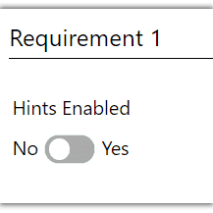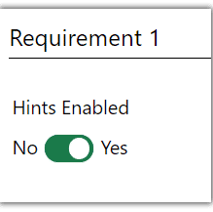

The **Lab Manual** with a **Toggle** in the **No (off)** position.

The **Lab Manual** with a

**Toggle** in the **Yes (on)** position.

#### Example of a Toggle

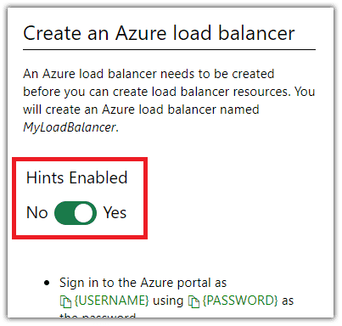

The **Lab Manual** with a **Toggle** highlighted in **red**.

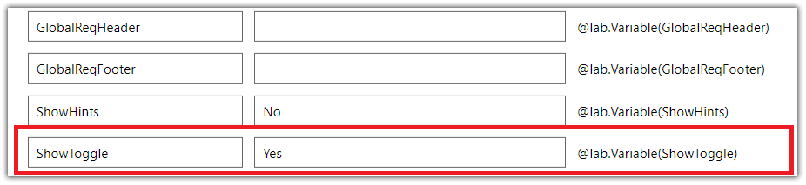

The **Lab Variables Window** with **ShowToggle** set to Yes, highlighted in **red**.

#### Showing or Hiding the Toggle

Select the **@Lab** icon located in the upper left-hand corner of the Edit Instructions window to access the Lab Variables.

1

Select the **Variables** tab located in the upper left-hand corner of the Edit Instructions window to access the Lab Variables.

2

Set the **ShowToggle** variable value to **Yes**.

3

To turn the Toggle **off**, repeat the above steps, and then set the variable value to **No**.

4

#### Additional Information

Toggles are Off by default in Guided and Expert Challenge Labs.

Toggles are On by default in Advanced Challenge Labs.

**CONTINUE**

*Lesson 21 of 25*

# CHALLENGE LAB STRUCTURE

 **Michael Kemper**

All three types of Challenge Labs share the same basic **structure**. They all contain an overview that sets the scene for the Challenge Lab and outlines the tasks the learner will perform, a series of tasks that contain the conﬁguration requirements the learner will perform, and a summary that highlights what the learner accomplished and provides information about related content that learners can use to build skills.

## No matter the type, each Challenge Lab:

Contains an overview that sets the scene for the Challenge and outlines the tasks the learner will perform.

Is driven by a series of tasks that contain the conﬁguration requirements the learner will perform.

Serves as a means of veriﬁcation, allowing the learner to gauge success.

Summarizes and highlights what the learner accomplished and provides information about related content that learners can use to build skills.

**CONTINUE**

*Lesson 22 of 25*

# CREATING THE TITLE PAGE

**Michael Kemper**

Leamer Prev,ew *,P* Sbll.:,blo Cl-.ollong..

Ch.al!enge Lab Template - (\13) (COPY) =

2 Hours11iemaining

I instructions H,elp Cl.. •

**.t:**

**nsk11lable**

✓-

**vV1 challenges**

**Advanced**

Challllenge Title Here

**Chal'lenge Overview**

Understand the scena11io

You a a Develc,per ar Hexelo, a company !hat eds. o..-. im you \'lll [ EQL'JIR IE **1].** ext, ycu **wrn** EQUIRBMEN 21,a d t'. - yo **\'ml**

[ EQL'JI 3], maHy, l/0' I'- I [R5RQUIR E 4],

Navigating tlhe Challenge lab

**0 **

**0** Quick ips- r vtga!ing he Ollallenge lab instrm:ilions. A

S�ec the Gopy 1:o Oipboard im to copy·*he* gree text.

Select ,h· ype eld icon,o insert the gree text dire into the C.fla lenge 'b em· • i.en·

An A.a , te!ls yo,u , err.; task requires extra care.

A Note provides dilio al lpful• fom a!ic··o:r com• eti a ta1;lo:.

AH- twiHg 'de b.

thro gh a pc ··on o· ihe O.llal,e:n.g:e

A Kno edge block pm·desa deeper evel c,f r.ov,,edge

* to a subjec· II isa great way ii:o so!id·- ye r

understar. •ing, b it• not st• n ecess:ary to comp ete

11*e* OhiaUffige Lab.

N*e:>:t*Ma:rkdO\'m sty, es that can be sed: )

The **Lab Manual** with the **Challenge Lab Title** page.

**CONTINUE**

## Github includes

Every **Challenge Lab** begins with a link to Github named !INSTRUCTIONS [ ], directly followed by a link. **DO NOT REMOVE** this link! The link is listed below:



**!INSTRUCTIONS[]**

**(https: /raw.githubusercontent.com /LODSContent/Challenge-V3- Framework/main/Templates/Sections/Intro.md)**

#### Github view

!INSTRUCTIONS[](https://raw.githubusercontent.com/LODSContent/Challenge-V3- Framework/main/Templates/LevelSpeciﬁc/Logos/@lab.Variable(dificulty).md)

# !INSTRUCTIONS[][challenge-title]

:::overviewbutton Challenge Overview

:::

@lab.Variable(GlobalIntroduction)

## Understand the scenario

!INSTRUCTIONS[][overview]

!INSTRUCTIONS[](https://raw.githubusercontent.com/LODSContent/Challenge-V3- Framework/main/Templates/Sections/LabHelp.md)

@lab.DropDownList(ShowToggle)[Yes,No]

**CONTINUE**

#### Skillable Challenges logo

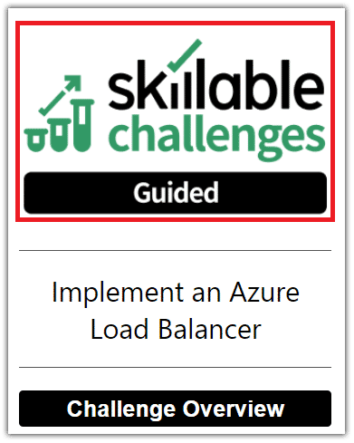

The **Lab Manual** with the **Skillable Challenges logo** highlighted in **red**.



**Skillable Challenge logos** that start the lab are set and updated based on the Challenge Lab level selected in the variables window. Entering Guided as the diﬃculty variable, will change the Challenge Lab image to Guided, Advanced to Advanced, and so on.

**The Challenge Lab Title**

### The **title** is one of the most important elements of a Challenge Lab. It tells the learners what they should be able to do when they have completed the challenge lab. All **titles** use title case.

#### Lab Manual View

|  |  |
| --- | --- |
| **sk1**✓**1**.**lable**  **challenges**  **,Guided**  Challlenge Title Her1e  **ChaUenge Overview**  Understand th,e scenario Navigatin,g the Challenge lab  **0** Undell"Standing a Cloud Slice **v**  **0** Ouick tips for navigating the Challenge Lab ins rue ions. v | |
|  | Select for More. |
| Next: Requireme **t 1** ) | |

The **Lab Manual** with the **Challenge Lab Title** highlighted in **red**.

#### iDLX Editor View

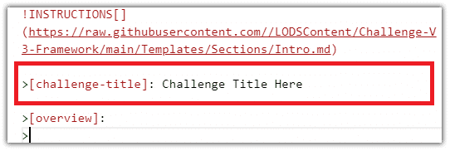

The **iDLX editor** with the **Title** markdown, highlighted in **red**.

#### Example of a Challenge Lab Title

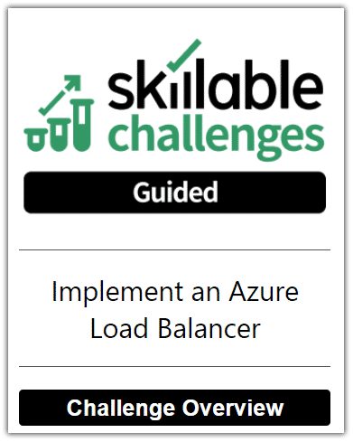

An example of a **Challenge Lab Title**.

#### Creating a Title

In the iDLX editor, locate the Title markdown. The markdown should look like the following:

1

**>[challenge-title]: Challenge Title Here**

Select the **Challenge Title Here** text, and then replace it with the

2

**new Title** text.

The new **Title** is now visible in the Lab Manual window.

3

#### Additional Information

A Guided challenge **title** must begin with an action verb.

Some **titles** may contain the name of the product or technology that is featured in the challenge lab.

If possible, avoid using the word and in a **title**.

In most cases, when you see the word "**and"**, you have two different Challenge Labs.

An Advanced or Expert Challenge Lab **title** is phrased in the form of a question and begins with the words “Can You …?”

The **title** should reﬂect the key skills being tested in the Challenge Lab.

**CONTINUE**

**The Overview**

### The challenge lab **overview** appears on the title page, under the Challenge Lab title, and contains a description of the

Challenge Lab scenario and a summary of the Challenge Lab environment. Learners must select the overview in order to display the contents, so some learners may not read this information.



The overview format is the same for all three types of Challenge Labs.

**The Overview is comprised of 3 important elements:**

The Scenario

1

The Job Title

2

The Company Name

3

#### The Scenario

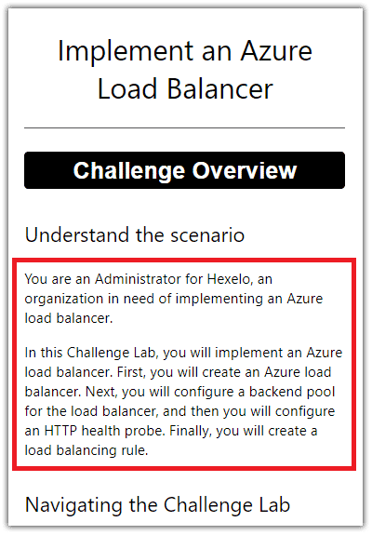

The **Lab Manual** with the **Scenario** highlighted in **red**.

#### iDLX Editor View

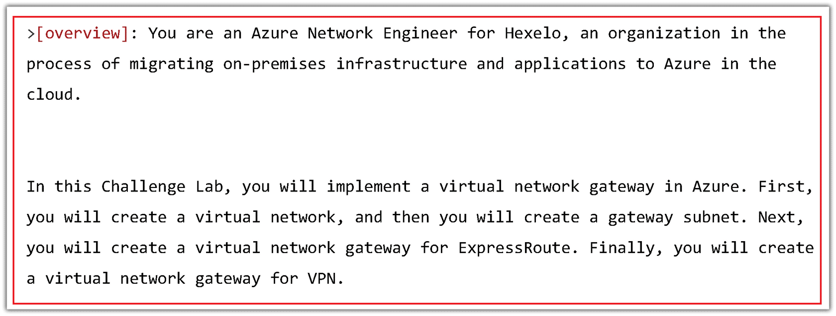

The **iDLX editor** with the **Scenario** markdown, highlighted in **red**.

#### Example of a Scenario

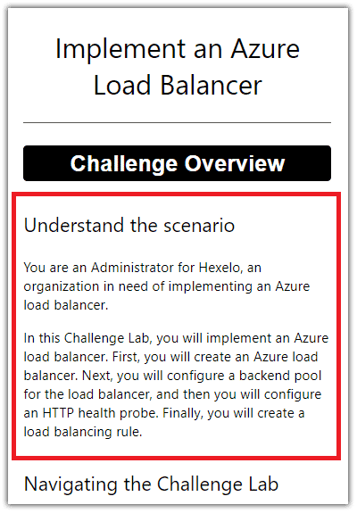

An example of a **Challenge Lab Scenario**.

#### Creating a Scenario

In the iDLX editor, locate the Overview markdown. The markdown should look like the following:

1

**>[overview]:**

**>**

**>**

**>**

**>**

To the right of **Overview**, enter your new Scenario. Don't forget to insert the Global variables for the Job Role and the Company Name.

2

The new **Scenario** is now visible in the Lab Manual window.

3

#### Additional Information

Each Challenge Lab contains an introductory paragraph that deﬁnes the job role, the Company name. and the requirements of the Challenge Lab, and the tasks the learner will perform.

Use the phrase "you need to" to introduce the main requirement of the Challenge Lab.

The second sentence should be in the form of a requirements statement that describes the overall goal of the Challenge Lab. Use the phrase “You need to…” to begin your requirements statement. The requirements statement should relate to the title.

The opening sentence should state one of the supplied Job Role tokens associated with the tasks in the Challenge Lab.

#### Challenge Lab Overview

|  |  |
| --- | --- |
| ✓.  **v**✓**v**,.**l sk11lable**  **challenges**  **,Guided**  **Challlenge Title** Heine,  **Challenge Overvi,ew**  Understand the sce11ario  Navi,gating the Challenge lab  **0** Understanding a Cloud Sli,oe **V**  **0** Quick tipcSfor navigating the Challenge lab ins rue ion.ss. **v** | |
|  | Select for Mo[e. |
| ext: Re,quirement **1** ) | |

The **Lab Manual** with the **Challenge Lab Overview** highlighted in **red**.

#### iDLX Editor View

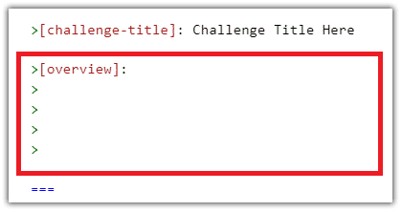

The **iDLX editor** with the **Overview** markdown, highlighted in **red**.

#### Example of an Overview



An example of a **Challenge Lab Overview**.

#### Global Variables

Don't forget to select the appropriate Job Role and Company Name token (Hexelo by default) from your list of populated variables, and then insert the **Token** into

the **Scenario.**

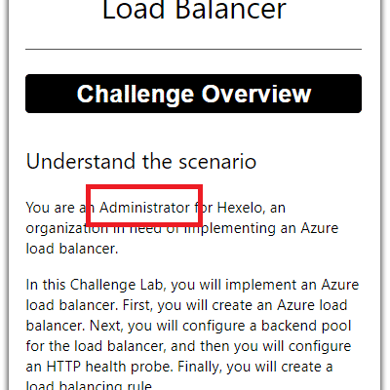 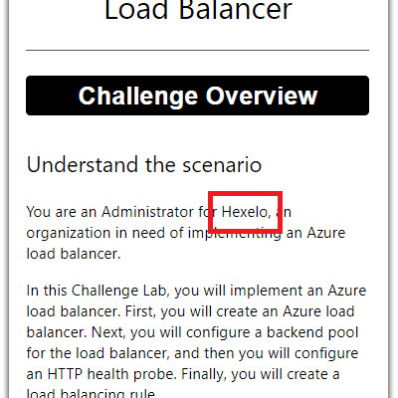 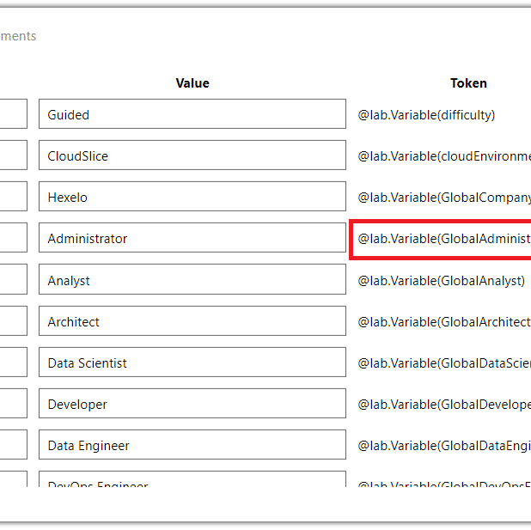

The **Lab Manual** with the **Job Role** highlighted in **red**.

The **Lab Manual** with the **Company Name** highlighted in **red**.

The **Variables window** with the **Job Role token** highlighted in **red**.

#### Creating an Overview

In the iDLX editor, locate the Overview markdown. The markdown should look like the following:

1

**>[overview]:**

**>**

**>**

**>**

**>**

To the right of **Overview**, enter your new Overview. Don't forget to insert the Global variables for the Job Role and the Company Name.

2

The new **Overview** is now visible in the Lab Manual window.

3

#### Additional Information

Stick to the pattern! Challenge Labs should all have a similar look and feel, and learners expect to see the same structure in each challenge lab they perform.

Authors should review the overview after completing all of the tasks in the challenge lab to ensure that the overview still describes the Challenge Lab correctly.

Tech reviewers and copy editors should review the overview at the end of their review to ensure that the overview describes the tasks in the Challenge Lab.



**Don't forget to insert the Global variables for the Job Role and the Company Name!**

**CONTINUE**

*Lesson 23 of 25*

# CREATING YOUR FIRST REQUIREMENT

 **Michael Kemper**

### Challenge Labs generally contain a minimum of 3 **Requirements**. **Requirements** are made up of Tasks. In Guided and Advanced Challenge Labs, the Tasks also contain Hints, which are made up of steps.

Once you we have created the Challenge Lab Title and Overview, we are ready to create our ﬁrst **Requirement**. Each Requirement is divided into it's own section.

Requirement sections begin with (*where the number increases as new Requirements are added*):

**===**

**<!-- Begin Requirement 1 section --> # Requirement 1**

and ends with:

!INSTRUCTIONS[]

(https://raw.githubusercontent.com/LODSContent/Challenge-V3- Framework/main/Templates/Sections/Footer.md)

**<!-- End Requirement 1 section -->**

#### Add a Requirement

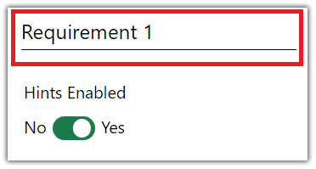

The **Lab Manual** with a **Requirement** highlighted in **red**.

#### iDLX Editor View

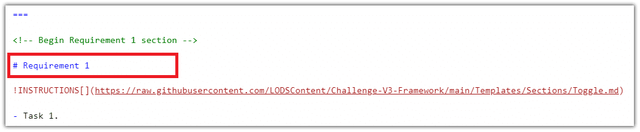

The **iDLX editor** with **Requirement** markdown, highlighted in **red**.

**Copy the below markdown to create a new Requirement:**



**# Requirement 1**

#### Example of a Requirement

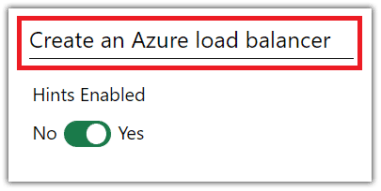

The **Lab Manual** with a **Requirement** highlighted in **red**.

#### Creating a Requirement

In the iDLX editor, locate the Requirement markdown. The Requirement 1 markdown will be located directly below the following:

1

**<!-- Begin Requirement 1 section -->**

The markdown should look like the following:

**# Requirement 1**

Select the **Requirement 1** text, and then replace it with the **new Requirement 1 text**.

2

**DO NOT REMOVE THE "#" SIGN!**

Repeat the above steps to add additional **Requirements**.

3

#### Additional Information

Before you begin to write the **Requirements** for your Challenge Lab, plan the Challenge Lab structure.

Think about the overall goal of the Challenge Lab, as well as the **Requirements** you want the learners to perform in order to achieve this goal.

Think of a **Requirement** as something that, in the real world, you would complete, and then feel that you could take a break.

Create a heading that calls out the purpose of the **Requirement**.

If your **Requirement** contains the word "**and"**, review the objectives. You may be trying to combine two **Requirements** into one.

**CONTINUE**

#### Add a Task

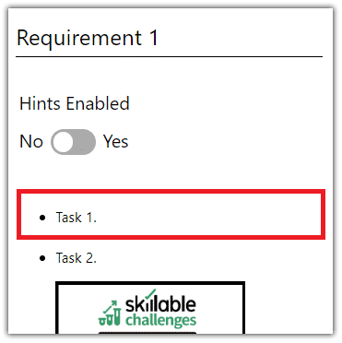

The **Lab Manual** with a **Task** highlighted in **red**.

#### iDLX Editor View

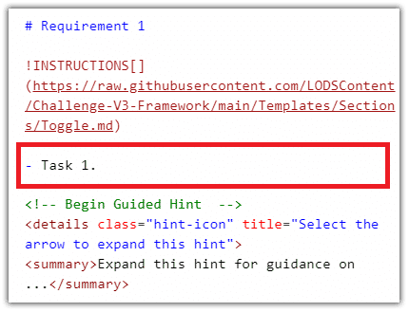

The **iDLX editor** with **Task** markdown, highlighted in **red**.

**Copy the below markdown to create a new Task:**



**- Task 1.**

**:::steps(ShowSteps=True)**

**>[+hint] Expand this hint for guidance on...**

**>**

* **There must be at least one blank line before the expandable content.**
* **Hints will be hidden when hints are oﬀ.**

**:::**

**>[!knowledge] Want to learn more? Review the documentation on**

**[creating Task #](https: /docs.microsoft.com/ "Create Task # Guidance"). Knowledge items are hidden when hints are oﬀ.**

#### Example of a Task

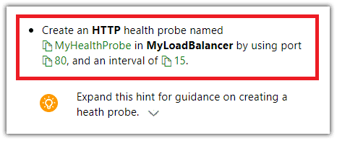

The **Lab Manual** with a **Task** highlighted in **red**.

#### Creating a Task

In the iDLX editor, locate the **Task** markdown. The Task 1 markdown will be located directly below the following:

1

**# Requirement 1**

!INSTRUCTIONS[]

(https://raw.githubusercontent.com/LODSContent/Challenge-

V3-Framework/main/Templates/Sections/Toggle.md)

The markdown should look like the following:

**- Task 1.**

:::steps(ShowSteps=True)

>[+hint] Expand this hint for guidance on...

>

* There must be at least one blank line before the expandable content.
* Hints will be hidden when hints are off.

:::

>[!knowledge] Want to learn more? Review the documentation on [creating Task #](https://docs.microsoft.com/ "Create Task # Guidance"). Knowledge items are hidden when hints are off.

Select the **- Task 1.** text, and then replace it with the **new Task 1 text**.

2

Repeat the above steps to add additional **Tasks**.

3

#### Additional Information

Write **Tasks** that tell the learner the action to take and the speciﬁc Requirements to implement, but not how to perform the action.

**Add Hints**

### For **Guided** Challenge Labs, don't forget to add detailed, step-by-step **Hints** to each **Task**.

**CONTINUE**

For **Advanced** Challenge Labs, don't forget to add **Hints** in the form of Links for additional learning to each **Task**.

*Lesson 24 of 25*

# ADDING THE CHECK YOUR WORK SECTION

 **Michael Kemper**

### Each Requirement in a Guided or Advanced Challenge Lab must contain a **Check your work** section after the tasks.

#### Lab Manual View

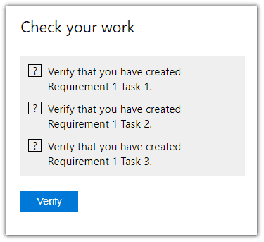

The **Lab Manual** with a **Check Your Work** section.

#### iDLX Editor View

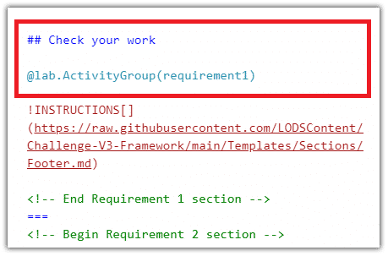

The **iDLX editor** with **Check Your Work** markdown, highlighted in **red**.

**Copy the below markdown to create a Check Your Work section:**



**## Check your work**

@lab.ActivityGroup(requirement1)

!INSTRUCTIONS[]

(https://raw.githubusercontent.com/LODSContent/Challenge-V3- Framework/main/Templates/Sections/Footer.md)

<!-- End Requirement 1 section -->

**===**

#### Example of a Check Your Work section

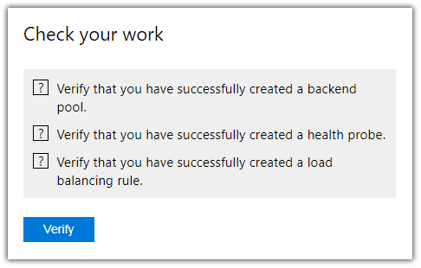

The **Lab Manual** with a **Check Your work** section.

**Each script contains three text elements:**

**Text** — Contains the veriﬁcation label that describes what the script veriﬁes.

**Correct Answer Feedback** — Contains the success message to display if the learner performed the conﬁguration correctly.

**Incorrect Answer Feedback** – Contains feedback to let the learner know what still needs to be conﬁgured



The incorrect answer feedback should be speciﬁc enough that the learner can determine what was missed.

#### Creating a Check Your Work section

In the iDLX editor, locate the **Check Your Work** markdown. The markdown should look like the following:

1

**## Check your work**

@lab.ActivityGroup(requirement1)

!INSTRUCTIONS[]

(https://raw.githubusercontent.com/LODSContent/Challenge- V3-Framework/main/Templates/Sections/Footer.md)

<!-- End Requirement 1 section -->

**===**

Select the **@lab.ActivityGroup(requirement1)** token, and then replace it with the **new Requirement Group token** from the **Activities** window.

2

Repeat the above steps to add additional **Check Your Work**

3

sections.



Tech reviewers should execute the script before performing the

Requirement. The script should display the incorrect answer feedback text if no conﬁguration has been performed.

Copy editors will need to run the Challenge Lab to see the script text,

and then execute the script to view the incorrect answer feedback

message. The script is included in a Word document for review, so copy editors can edit the text, including punctuation.

#### Additional Information

Each point should begin with the word Conﬁrm.

Each point should represent a key outcome of the Requirement, but may not map directly to each task .

Check your work statements will map to the individual Tasks. They should never contain information that was not covered in the Requirement.

Do not put veriﬁcation instructions in the Check your work section. If learners should perform a veriﬁcation step, include this in the tasks.

The check your work section in an Advanced Challenge Lab should contain at least one activity script that will verify whether or not a learner has successfully performed the conﬁguration required in the task.

The script should verify that the key outcome of the task was completed, and may also verify additional conﬁguration changes required by the task.

**CONTINUE**

*Lesson 25 of 25*

# ADDING THE SUMMARY SECTION

 **Michael Kemper**

### The **Summary** section summarizes the tasks learners performed in the Challenge Lab. The list of Requirements should relate directly to the abstract you used in the Challenge Lab Overview. Always use the past tense, and use active verbs.

#### Lab Manual View

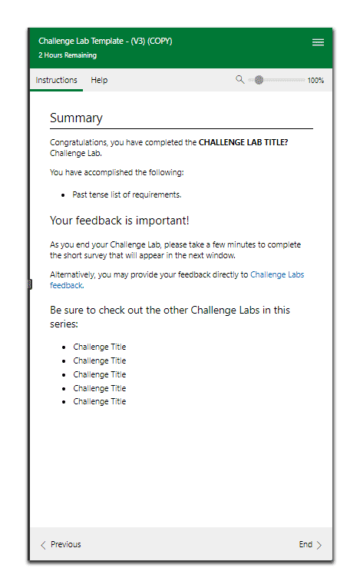

The **Lab Manual** with a **Summary** section.

#### iDLX Editor View

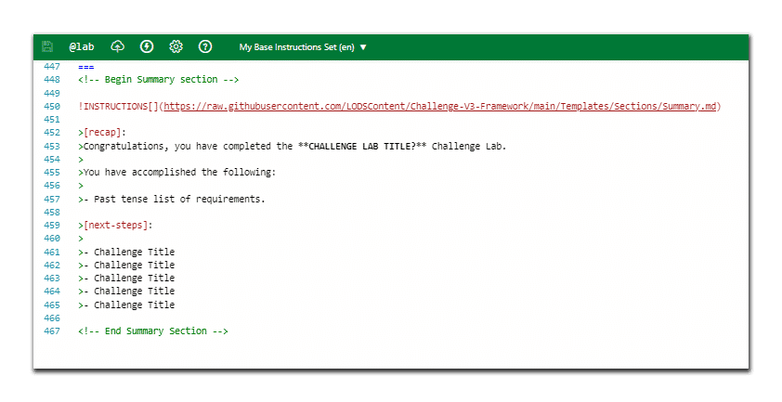

The **iDLX editor** with **Summary** markdown, highlighted in **red**.

**Summary Section: Github**

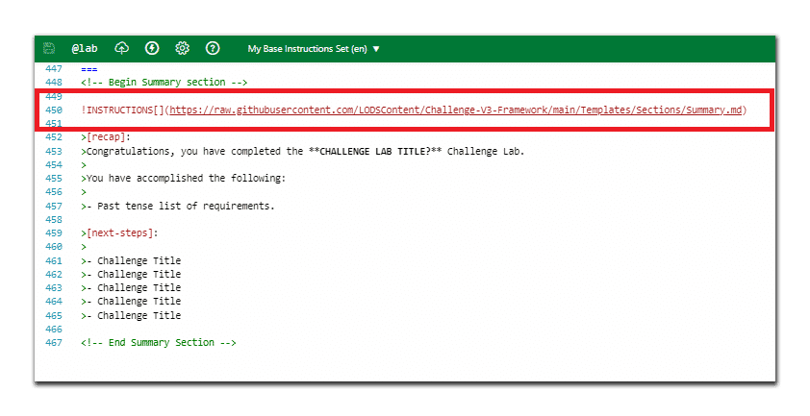

The **iDLX editor** with **Github** markdown, highlighted in **red**.

Below is a description of what is included within the Github link:

**# Summary**



**<!-- Show submit warning on expert labs -->**

**!INSTRUCTIONS[](https://raw.githubusercontent.com/LODSContent/Challenge- V3-**

**Framework/main/Templates/LevelSpeciﬁc/Summary/@lab.Variable(diﬃculty).md)**

**!INSTRUCTIONS[][recap]**

**!INSTRUCTIONS[](https://raw.githubusercontent.com/LODSContent/Challenge- V3-Framework/main/Templates/Sections/Feedback.md)**

**### Be sure to check out the other Challenge Labs in this series:**

**!INSTRUCTIONS[][next-steps] @lab.Variable(GlobalSummary)**

**Summary Section: Challenge Lab Title**



The **iDLX editor** with **Challenge Lab Title** markdown, highlighted in **red**.

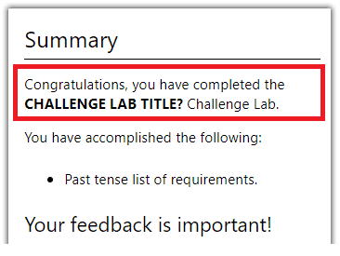

The **Lab Manual** with **Challenge Lab Title**, highlighted in **red**.

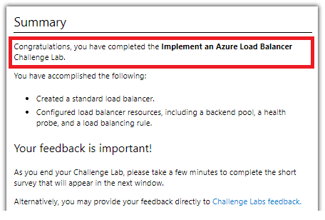

An **Example** with **Challenge Lab Title**, highlighted in **red**.

**Summary Section: List of Requirements**

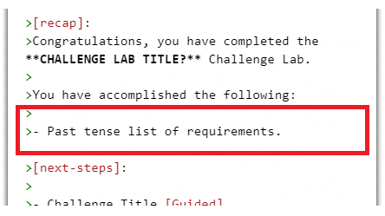

The **iDLX editor** with **Challenge Lab Requirements** markdown, highlighted in **red**.

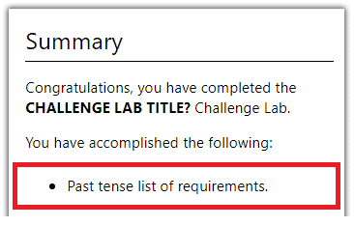

The **Lab Manual** with **Challenge Lab Requirements**, highlighted in **red**.

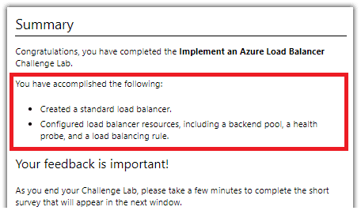

An **Example** with **Challenge Lab Requirements**, highlighted in **red**.

**Summary Section: List of other Challenge Labs in series**

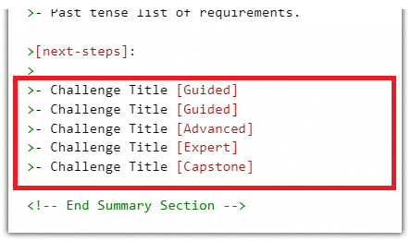

The **iDLX editor** with additional **Challenge Labs** markdown, highlighted in **red**.

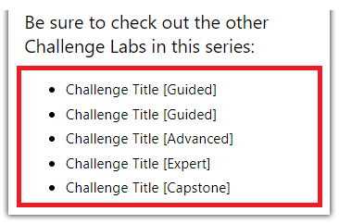

The **Lab Manual** with additional **Challenge Labs**, highlighted in **red**.

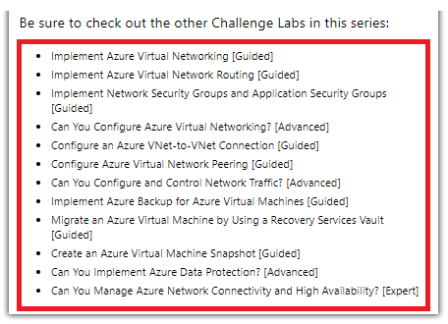

An **Example** with additional **Challenge Labs**, highlighted in **red**.

**Copy the below markdown to create a Summary section:**



**<!-- Begin Summary section -->**

**!INSTRUCTIONS[]**

**(https://raw.githubusercontent.com/LODSContent/Challenge-V3- Framework/main/Templates/Sections/Summary.md)**

**>[recap]:**

**>Congratulations, you have completed the **CHALLENGE LAB TITLE?**

**\*\* Challenge Lab.**

**>You have accomplished the following:**

**>**

**>- Past tense list of requirements.**

**>[next-steps]:**

**>**

**>- Challenge Title**

**>- Challenge Title**

**>- Challenge Title**

**>- Challenge Title**

**>- Challenge Title**

**<!-- End Summary Section -->**

#### Example of a Summary section

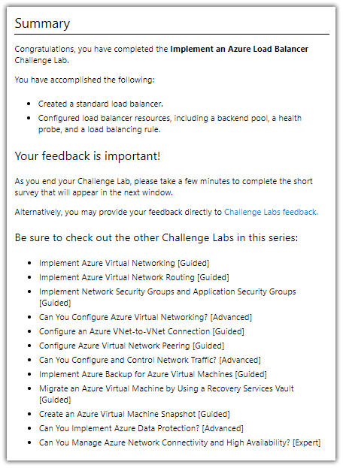

The **Lab Manual** with a **Summary** section.

#### Creating a Summary

In the iDLX editor, locate the **Summary** section markdown. The markdown should look like the following:

1

**===**

<!-- Begin Summary section -->

!INSTRUCTIONS[]

(https://raw.githubusercontent.com/LODSContent/Challenge- V3-Framework/main/Templates/Sections/Summary.md)

**>**[recap]:

**>**Congratulations, you have completed the \*\***CHALLENGE LAB TITLE?**\*\* Challenge Lab.

**>**You have accomplished the following:

**>**- Past tense list of requirements.

**>**[next-steps]:

**>**- Challenge Title [Guided]

**>**- Challenge Title [Guided]

**>**- Challenge Title [Advanced]

**>**- Challenge Title [Expert]

**>**- Challenge Title [Capstone]

<!-- End Summary Section -->

Select the **\*\*CHALLENGE LAB TITLE?\*\***, and then replace it with the **new Challenge Lab Title**.

2

Select the **- Past tense list of requirements.**, and then replace it with the **new list of requirements**.

3

Repeat the above step to add additional **Requirements**.

4

Below [next-steps], select the **- Challenge Title [Guided]**, and then replace it with the **new list of Challenge Labs** in the series.

5

*List ALL of the* ***Challenge Labs*** *in the series.*

Repeat the above step to add additional **Challenge Labs**.

6

#### Additional Information

At the end of the Summary, provide a list ALL of other, related Challenge Labs in the series.

The Summary section contains some boilerplate text as part of the template. You will need to add your Challenge Lab Title.

*Please ensure that this matches the ﬁnal title for the Challenge Lab.*

**CONTINUE**